  
 ADHIYAMAAN COLLEGE OF ENGINEERING (AUTONOMUS)

HOSUR-635109

DEPARTMENT OF COMPUTER SCIENCE AND ENGINEERING

AI BASED DISCOURSE FOR BANKING INDUSTRY

TEAM ID: PNT2022TMID07965

**PROJECT GUIDED** BY

A LAVANAYA

(ASSISTANT PROFESSOR)

**TEAM MEMBERS:**

ABHISHEK U - AC19UCS001

CHARAN N - AC19UCS018

KARTHIKEYAN M - AC19UCS048

KALYAN KUMAR K - AC19UCS046

# CONTENTS

1. **INTRODUCTION**
   1. Project Overview
   2. Purpose
2. **LITERATURE SURVEY**
   1. Existing problem
   2. References
   3. Problem Statement Definition
3. **IDEATION & PROPOSED SOLUTION**
   1. Empathy Map Canvas
   2. Ideation & Brainstorming
   3. Proposed Solution
   4. Problem Solution fit
4. **REQUIREMENT ANALYSIS**
   1. Functional requirement
   2. Non-Functional requirements
5. **PROJECT DESIGN**
   1. Data Flow Diagrams
   2. Solution & Technical Architecture
   3. User Stories
6. **PROJECT PLANNING & SCHEDULING**
   1. Sprint Planning & Estimation
   2. Sprint Delivery Schedule
   3. Reports from JIRA
7. **CODING & SOLUTIONING (Explain the features added in the project along with code)**
   1. Feature 1
   2. Feature 2
   3. Database Schema (if Applicable)
8. **TESTING**
   1. Test Cases
   2. User Acceptance Testing
9. **RESULTS**
   1. Performance Metrics
10. **ADVANTAGES & DISADVANTAGES**
11. **CONCLUSION**
12. **FUTURE SCOPE**
13. **APPENDIX**

Source Code

GitHub & Project Demo Link

# INTRODUCTION

## Project Overview

This project, titled “AI Based Discourse for Banking Industry”, aims at providing a platform for customers to clarify their queries online regarding banking. This is achieved with the help of a chatbot that is trained with some of the most frequently asked questions that banking customers usually tend to come up with. The chatbot is created using IBM Watson Assistant and is trained by manually adding the queries to it along with the relevant responses. The chatbot will then be available for use on a website which usually is the bank’s website for anyone to access.

Customers or anyone in fact can access the chatbot to interact with it and find solutions to their queries.

## Purpose

With banking being an essential service that people require and with it being a slightly complicated and confusing topic for many, a lot of queries naturally tend to arise. For them to be answered as they are predominantly now in a manual aspect either by face to face interactions with a banking employee or through a customer care service, will require a lot of workforce and still end up with long waiting times. Hence, comes the need for an automated solution to the problem which can be easily handled by our chatbot. A chatbot is free, easy to use and is readily accessible at all times and from anywhere. It also provides instant reliable answers to queries and hence eliminating the need for the customers to wait to get their queries cleared. It also ensures that there is no spread of misinformation by providing official and authentic responses to queries straight from the bank sources.

* 1. **Existing problem**

# LITERATURE SURVEY

Banks are not able to resolve the queries of customers at all times related to the products or services in a satisfactory way which in turn hinders the customer satisfaction. Customers need to visit banks frequently for simple queries.

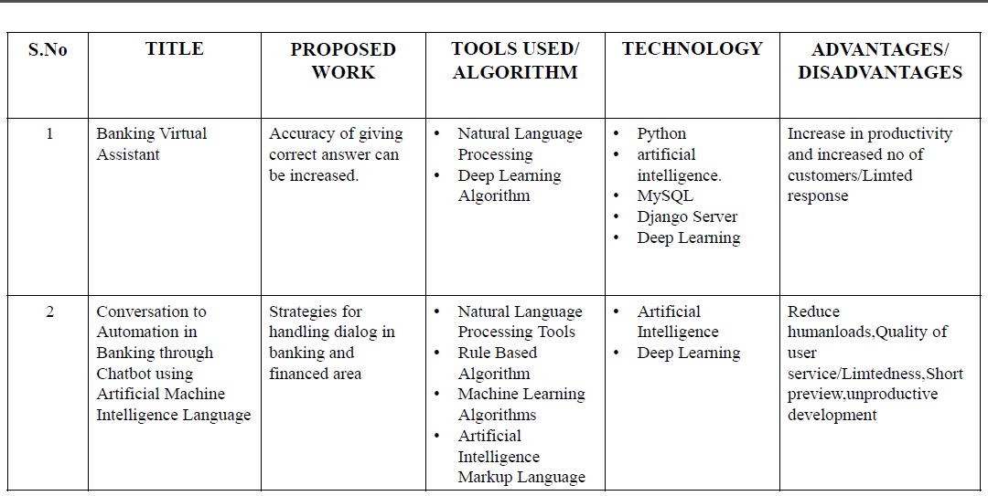

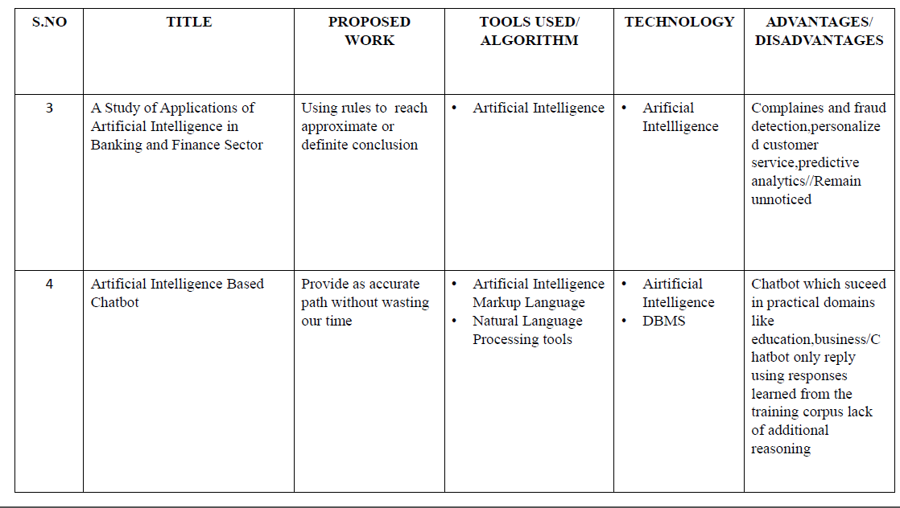

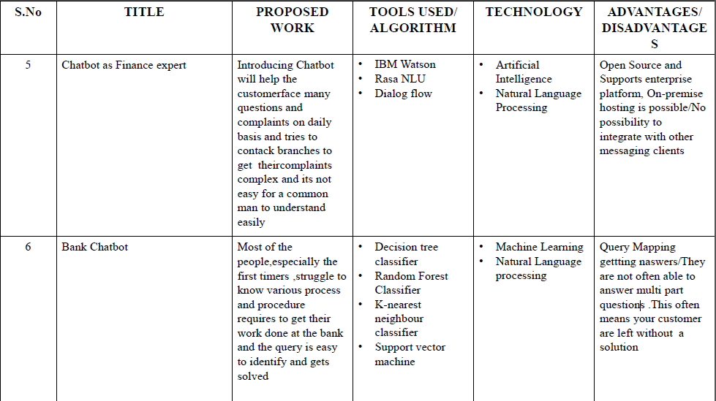

## Problem Statement Definition

Banking is one the crucial sectors, it deals with financial transactions which can be availed by everyone, but banks are not able to resolve the queries of customers at all times related to the products or services in a satisfactory way in turn hinders the customer satisfaction. In order to guide the customers throughout all the financial services provided by the bank, an intelligent system has to be introduced to provide people with the best solution possible. The users are bank customers who need 24/7 service to clear all their queries and guide them through all the banking processes. So, an enhanced and smarter way of interaction with the customers has to be built to ensure efficient delivery of service. In order to overcome the user satisfaction issues associated with banking services, chatbot will provide personal and efficient communication between the user and the bank. It is built to be the overall virtual assistant that can facilitate customers to ask banking- related questions without visiting the bank or calling up customer service centers as well as providing them with relevant suggestions.

## IDEATION AND PROPOSED SOLUTION

* 1. **Empathy Map Canvas**

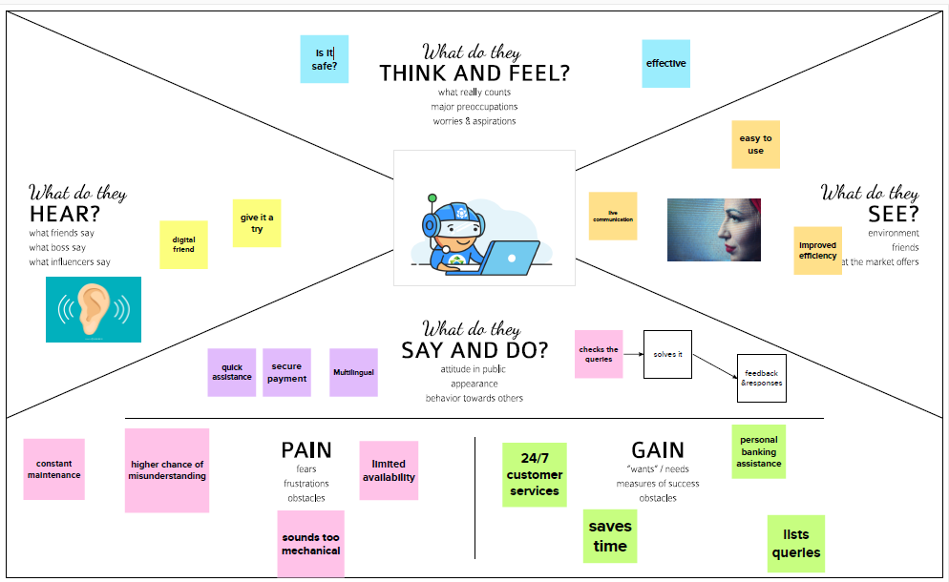

## 3.2Ideation & Brainstorming

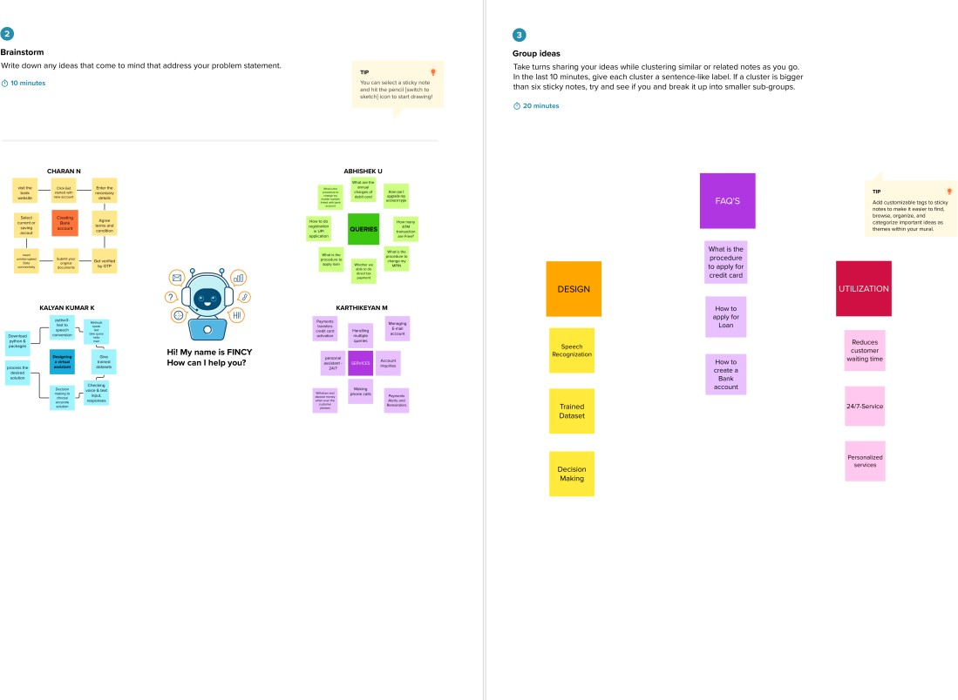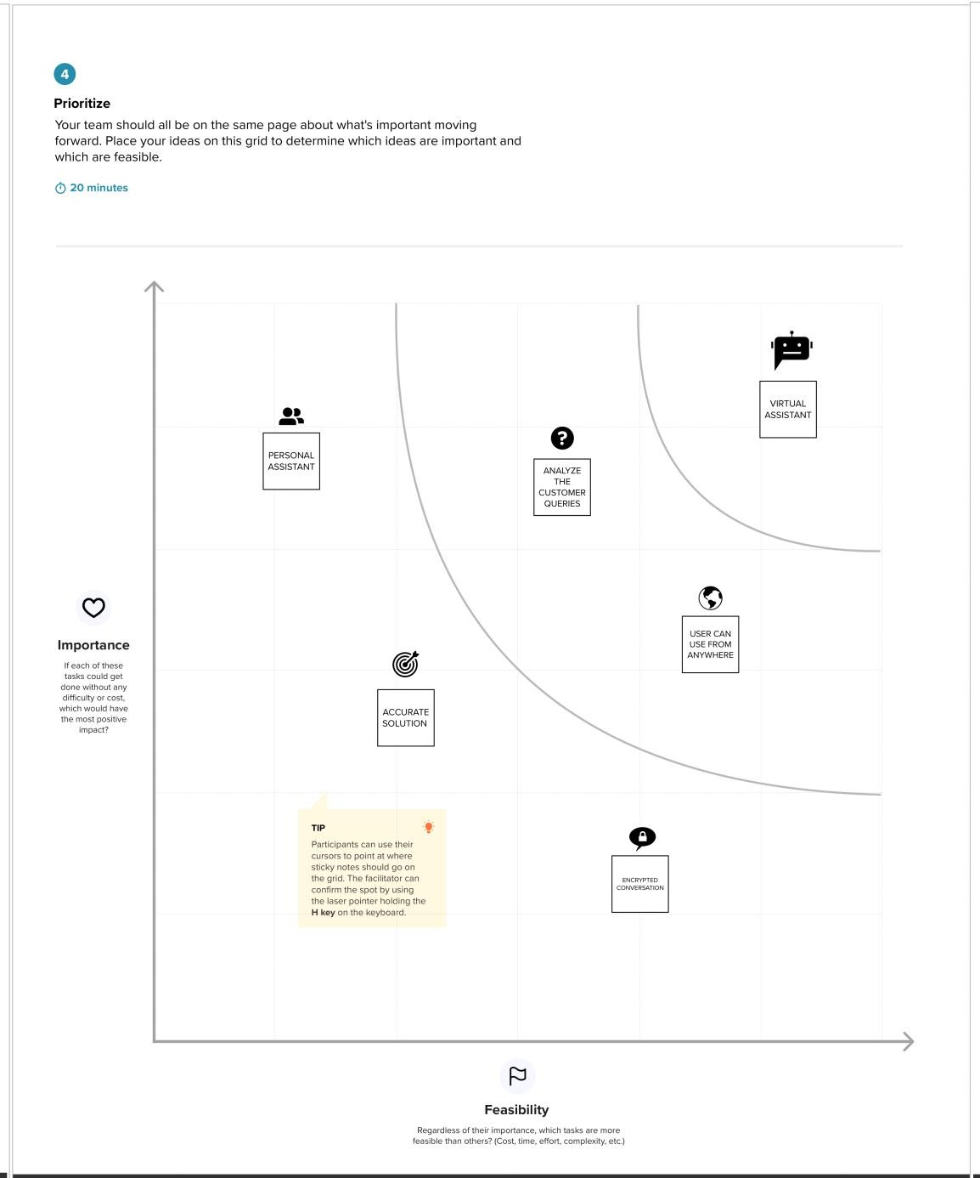

* 1. **Proposed Solution**

|  |  |  |
| --- | --- | --- |
| **S.NO** | **PARAMETER** | **DESCRIPTION** |
| 1. | Problem Statement (Problem to be solved) | User's who needs to solve his/her queries through an Virtual Assistant for Banking Sector |
| 2. | Idea / Solution description | The proposed solution is to solve multiple queries to give best solutions(higher accuracy) by using NLP and deep learing techniques. |
| 3. | Novelty / Uniqueness | For detecting the queries, We use an efficient methods where we have pre-vt defined trained dataset for attaining  higher accuracy solutions. |
| 4. | Social Impact / Customer Satisfaction | By this model the customer can efficiently keep track of their queries and accordingly get required  consultations in a less time consuming manner. |
| 5. | Business Model (Revenue Model) | * Input module * Categorize the given queries * Data set training module * deliver automated smart responses * Suggestion module. |
| 6. | Scalability of the Solution | AI Chatbots provides 24/7 service to clear all customer queries and guide them through all the banking processes. It supports voice assistance feature and maintains a confidential  conversation with customers. It can be scaled as per the requirements of the bank to include answers to queries related to any new feature or service introduced by the bank. |

## Problem Solution fit

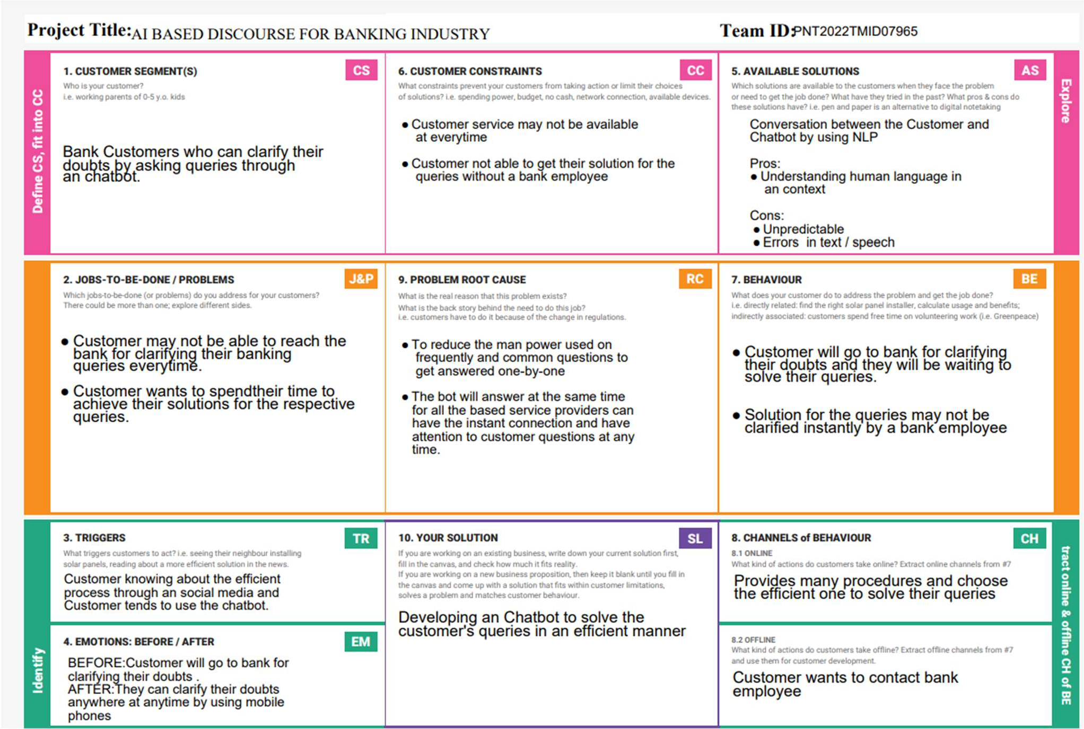

1. **REQUIREMENT ANALYSIS**

## Functional requirements

|  |  |  |
| --- | --- | --- |
| **FR NO.** | **FUNCTIONAL REQUIREMENT (EPIC)** | **SUB REQUIREMENT (STORY / SUB-TASK)** |
| FR-1 | Savings Account Related Actions | * Type of Savings Account Creation Details * Interest Rate * Minimum Balance * Debit Card * Credit Card |
| FR-2 | Current Account Related Actions | * Type of Company * Current Account Closure Steps * Update GSTIN * Zero Balance Current Account |
| FR-3 | Loan Account Related Actions | * Type of Loan * How long for approval * Available Loan Amounts * Loan Status * Joint Loan |
| FR-4 | General Queries Related Actions | * Bank Working Days * List of Branches * Storage Locker Facility * Currency Conversion Facility * CIBIL * Find a nearest branch |
| FR-5 | Net Banking Related Actions | * Login Steps * Change Net Banking Password * Daily Limit * Types of Fund Transfer * Add Beneficiary |

* 1. **Non-Functional requirements**

|  |  |  |
| --- | --- | --- |
| **NFR NO.** | **NON-FUNCTIONAL REQUIREMENT** | **DESCRIPTION** |
| NFR-1 | Usability | Chatbots developed using AI should be able to answer any general banking queries on account creation, loan, net banking, other services etc. It addresses the queries of customers immediately  and effectively in a cost efficient manner. |
| NFR-2 | Security | The AI Chatbot maintains a confidential conversation with customers. Chatbot will provide personal and efficient communication between the  user and the bank. |
| NFR-3 | Reliability | Chatbots are trained very well using AI to provide solutions for the popular and frequently asked questions, thereby providing the best suited service quickly. Thus AI Chatbots has a reliable end-user  experience. |
| NFR-4 | Performance | AI Chatbots are a great way to overcome the limitation of workload of humans. There can be multiple instances of a single chatbot inquiring about different people at the same time. Such chatbots work in real time with no need for the customers to wait. This ensures faster, easier and more efficient  face-time with customers. |
| NFR-5 | Availability | AI Chatbots provide 24/7 service to clear all customer queries and guide them through all the banking processes. It is available to anyone with  access to the internet with basic hardware. |
| NFR-6 | Scalability | AI Chatbots are helping the banking industry to scale their customer service and to improve customer service satisfaction at the same time. It can be scaled as per the requirements of the bank to include answers to queries related to any new feature or service introduced by the bank. |

* 1. **Data Flow Diagrams**

# PROJECT DESIGN

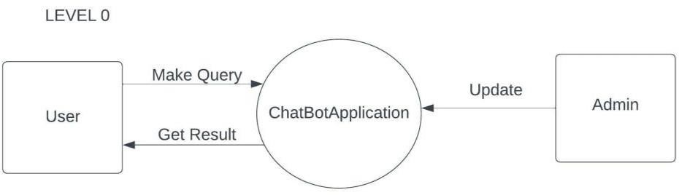

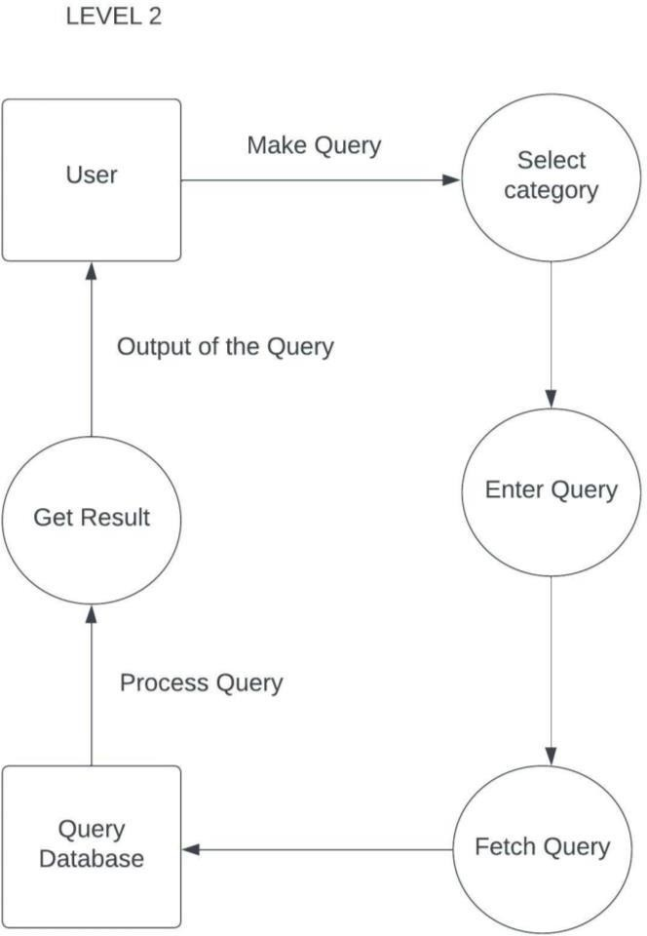

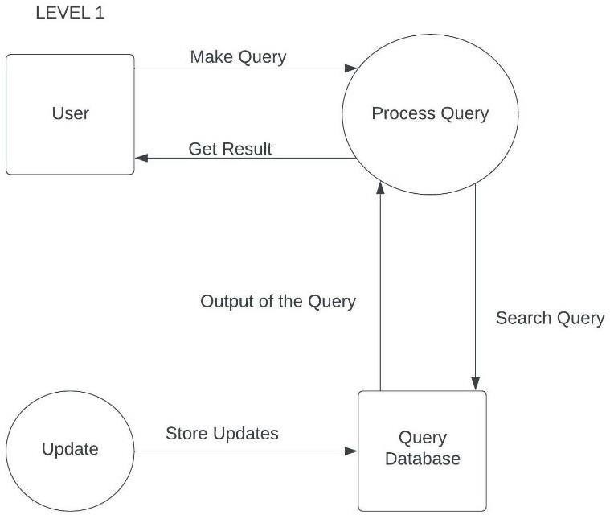

## Solution & Technical Architecture Solution Architecture

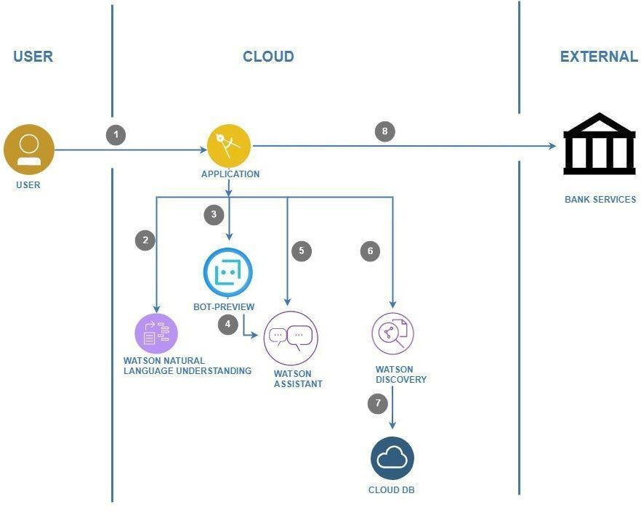**Technical Architecture**

* 1. **User Stories**

|  |  |  |  |  |  |  |
| --- | --- | --- | --- | --- | --- | --- |
| **USER TYPE** | **FUNCTIONAL REQUIREMENT**  **(EPIC)** | **USER STORY NUMBER** | **USER STORY / TASK** | **ACCEPTANCE CRITERIA** | **PRIORITY** | **RELEASE** |
| Customer (Mobile or Web user) | Savings Account Related Actions | USN-1 | As a user, in the Savings Account option, I can select Types of Savings Account to get details regarding documents required for creating that savings account. | I can clear my queries regarding types of savings account | High | Sprint-1 |
|  |  | USN-2 | As a user, I can check the Interest Rates of Savings Account | I can clear my queries regarding interest rates of savings account | High | Sprint-1 |
|  |  | USN-3 | As a user, I can check the Minimum Balance of Savings Account | I can clear my queries regarding minimum balance of  savings  account | Medium | Sprint-2 |
|  | Current Account Related Actions | USN-4 | As a user, I can choose the Type of Company to know the information on documents to be submitted for creating current account | I can clear my queries regarding types of companies | High | Sprint-1 |
|  |  | USN-5 | As a user, I want to get details on procedure to close my Current Account | I can clear my queries regarding current account closure | High | Sprint-2 |
|  | Loan Account Related Actions | USN-6 | As a user, I can choose the Type of Loans to know the information on choosing an essential loan scheme | I can clear my queries regarding types of loan account | High | Sprint-1 |
|  |  | USN-7 | As a user, I can check the Loan Amounts that can be offered for corresponding Loan Accounts chosen | I can clear my queries regarding loan amounts of loan account | High | Sprint-2 |
|  |  | USN-8 | As a user, I can check the Status of Loan for my Loan Accounts | I can clear my queries regarding loan status of loan account | Low | Sprint-2 |

|  |  |  |  |  |  |  |
| --- | --- | --- | --- | --- | --- | --- |
| **USER TYPE** | **FUNCTIONAL REQUIREMENT (EPIC)** | **USER STORY NUMBER** | **USER STORY / TASK** | **ACCEPTANCE CRITERIA** | **PRIORITY** | **RELEASE** |
|  |  | USN-10 | As a user, I want to check my CIBIL score for my loan application and to ensure whether my loan application is approved by the bank. | I can clear my queries regarding CIBIL score of loan application | Medium | Sprint 3 |
|  |  | USN-11 | As a user, I want to get the procedure details for maintaining Storage Locker facility of my bank account | I can clear my queries regarding storage locker facilities of bank account | High | Sprint-3 |
|  | Net Banking Related Actions | USN-12 | As a user, I want to get the procedure details for changing the Net  Banking password of my bank account | I can clear my queries regarding change of net banking password | Medium | Sprint-2 |
|  |  | USN-13 | As a user, I can select types of fund transfers to get details regarding different services available in net banking | I can clear my queries regarding types of fund transfers in net banking | High | Sprint-3 |
|  |  | USN-14 | As a user, I want to get the procedure details for adding beneficiaries to my net banking account. | I can clear my queries regarding adding beneficiaries in net banking | Low | Sprint-3 |
| Administrator |  | USN-15 | As an admin, I can change responses to queries and modify them as and when needed. | I can modify responses of the chatbot | Medium | Sprint-1 |
|  |  | USN-16 | As an admin, I can add more options to queries and add new options as new features get added. | I can add more options and queries into the chatbot | Medium | Sprint-1 |

# PROJECT PLANNING AND SCHEDULING

## Sprint Planning & Estimation

|  |  |  |  |  |  |  |
| --- | --- | --- | --- | --- | --- | --- |
| **SPRINT** | **FUNCTIONAL REQUIREMENT (EPIC)** | **USER STORY NUMBER** | **USER STORY / TASK** | **STORY POINTS** | **PRIORITY** | **TEAM MEMBERS** |
| Sprint-1 | Savings Account Related Actions | USN-1 | As a user in Savings Account option, I can select the Type of Savings Account to get details regarding documents required for creating Savings Account | 4 | High | ABHISHEK  CHARAN  KALYAN KUMAR  KARTHIKEYAN |
| Sprint-1 |  | USN-2 | As a user, I can check the Interest Rates of Savings Account | 4 | High | ABHISHEK  CHARAN  KALYAN KUMAR  KARTHIKEYAN |
| Sprint-1 |  | USN-3 | As a user, I can check the Minimum Balance of Savings Account | 3 | Medium | ABHISHEK  CHARAN  KALYAN KUMAR  KARTHIKEYAN |
| Sprint-1 | Current Account Related Actions | USN-4 | As a user, I can choose the Type of Company to know the information on documents to be submitted for creating current account | 5 | High | ABHISHEK  CHARAN  KALYAN KUMAR  KARTHIKEYAN |
| Sprint-1 |  | USN-5 | As a user, I want to get details on procedure to close my Current Account | 4 | High | ABHISHEK  CHARAN |
| Sprint-2 | Loan Account Related Actions | USN-6 | As a user, I can choose the Type of Loans to know the information on choosing an essential loan scheme | 3 | High | KALYAN KUMAR  KARTHIKEYAN |
| Sprint-2 |  | USN-7 | As a user, I can check the Loan Amounts that can be offered for corresponding Loan Accounts chosen | 3 | High | CHARAN  KARTHIKEYAN |
| Sprint-2 |  | USN-8 | As a user, I can check the Status of Loan for my Loan Accounts | 1 | Low | ABHISHEK  KALYAN KUMAR |
| Sprint-2 | General Queries Related Actions | USN-9 | As a user, I want to get the procedure details for Currency Conversion facility  of my bank account | 2 | Medium | ABHISHEK  CHARAN  KALYAN KUMAR |
| Sprint-2 |  | USN-10 | As a user, I want to check my CIBIL score for my loan application and to ensure whether my loan application is approved by the bank. | 1 | Low | ABHISHEK  KARTHIKEYAN |
| Sprint-2 |  | USN-11 | As a user, I want to get the procedure details for maintaining Storage Locker facility of my bank account | 3 | High | CHARAN  KALYAN KUMAR |

|  |  |  |  |  |  |  |
| --- | --- | --- | --- | --- | --- | --- |
| Sprint-2 | Net Banking Related Actions | USN-12 | As a user, I want to get the procedure details for changing the Net Banking password of my bank account | 3 | High | ABHISHEK  KARTHIKEYAN |
| Sprint-2 |  | USN-13 | As a user, I can select types of fund transfers to get details regarding different services available in net banking | 2 | Medium | CHARAN  KALYANKUMAR |
| Sprint-2 |  | USN-14 | As a user, I want to get the procedure details for adding beneficiaries to my net banking account. | 2 | Medium | KARTHIKEYAN  CHARAN |
| Sprint-3 | Web Application | USN-15 | As a user, I want to access the chatbot in a web browser that can be accessed from almost all devices. | 20 | High | ABHISHEK  CHARAN  KALYAN |
| Sprint-4 | User Interface and Web Pages | USN-16 | As a user, I want to view pages of the banking website and have access to the chatbot easily. | 20 | High | ABHISHEK  KARTHIKEYAN |

* 1. **Sprint Delivery Schedule**

|  |  |  |  |  |  |  |
| --- | --- | --- | --- | --- | --- | --- |
| **SPRINT** | **TOTAL STORY POINTS** | **DURATION** | **SPRINT START DATE** | **SPRINT END DATE (PLANNED)** | **STORY POINTS COMPLETED (AS ON PLANNED END DATE)** | **SPRINT RELEASE DATE (ACTUAL)** |
| Sprint-1 | 20 | 6 Days | 24 Oct 2022 | 29 Oct 2022 | 20 | 26 Oct 2022 |
| Sprint-2 | 20 | 6 Days | 31 Oct 2022 | 05 Nov 2022 | 22 | 02 Nov 2022 |
| Sprint-3 | 20 | 6 Days | 07 Nov 2022 | 12 Nov 2022 | 20 | 09 Nov 2022 |
| Sprint-4 | 20 | 6 Days | 14 Nov 2022 | 19 Nov 2022 | 20 | 16 Nov 2022 |

|  |  |  |  |
| --- | --- | --- | --- |
| **SPRINT** | **TOTAL STORY POINTS** | **DURATION** | **AVERAGE VELOCITY** |
| Sprint-1 | 20 | 6 Days | 20/6 = 3.33 |
| Sprint-2 | 20 | 6 Days | 20/6 = 3.33 |
| Sprint-3 | 20 | 6 Days | 20/6 = 3.33 |
| Sprint-4 | 20 | 6 Days | 20/6 = 3.33 |
| **Overall** | **80** | **24 Days** | **80/24 = 3.33** |

## Velocity chart:

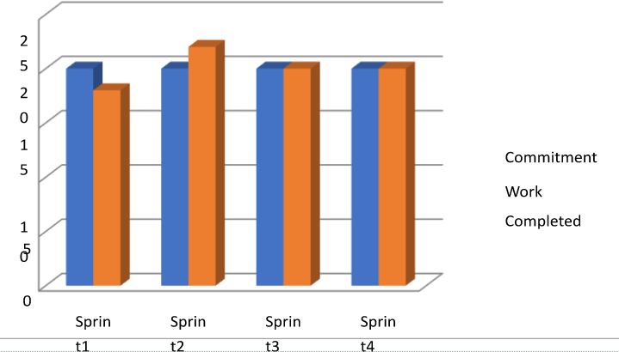

**Burn down chart:**

Sprint1

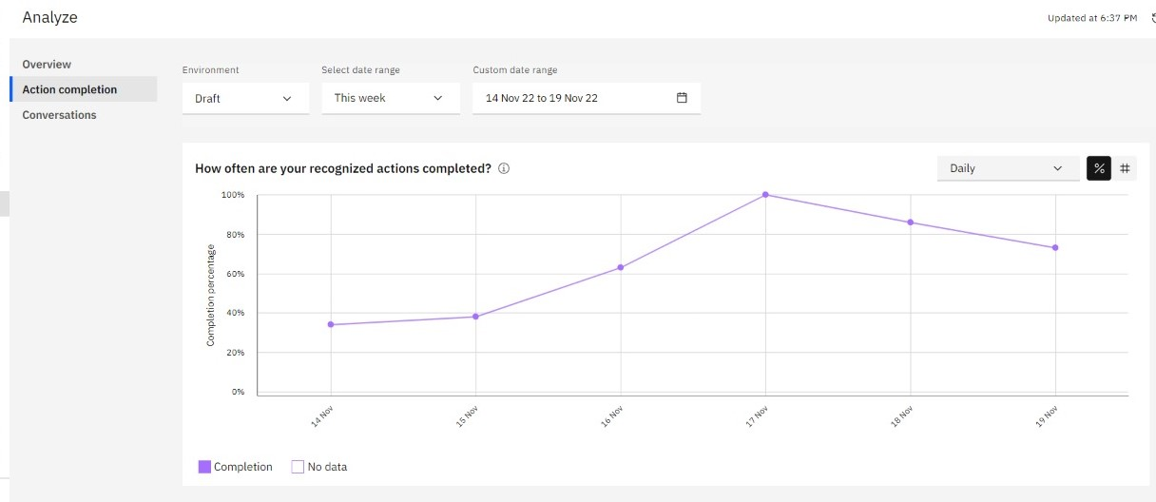

Sprint2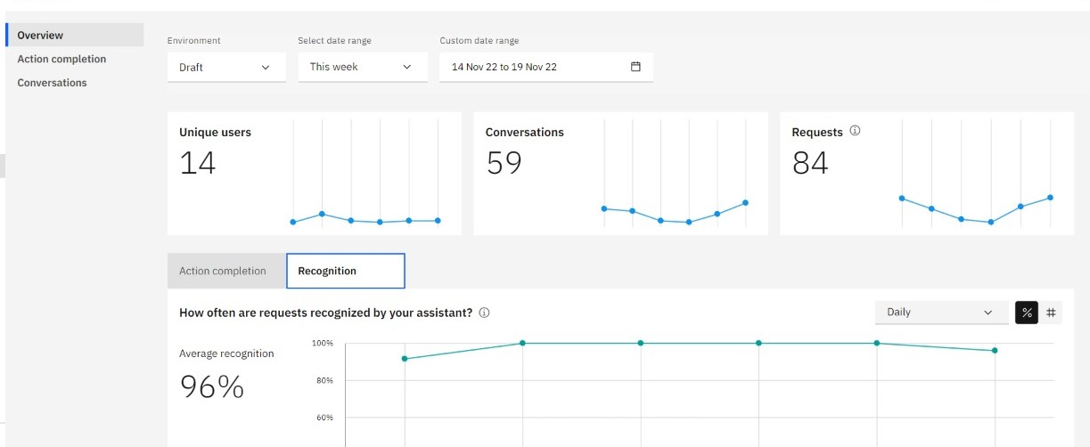

Sprint3



Sprint4

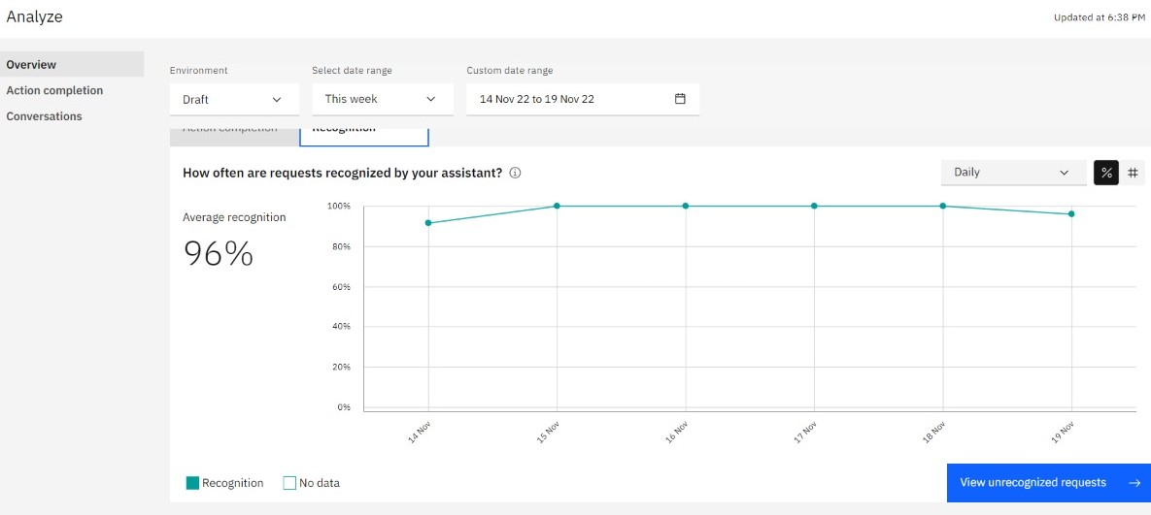

## 6.3Reports from JIRA

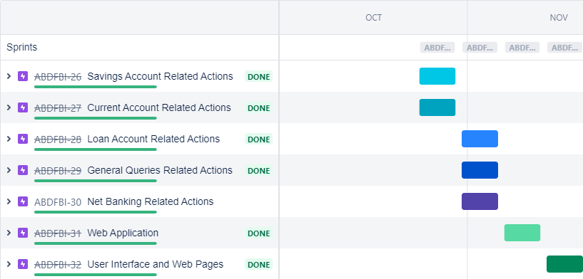

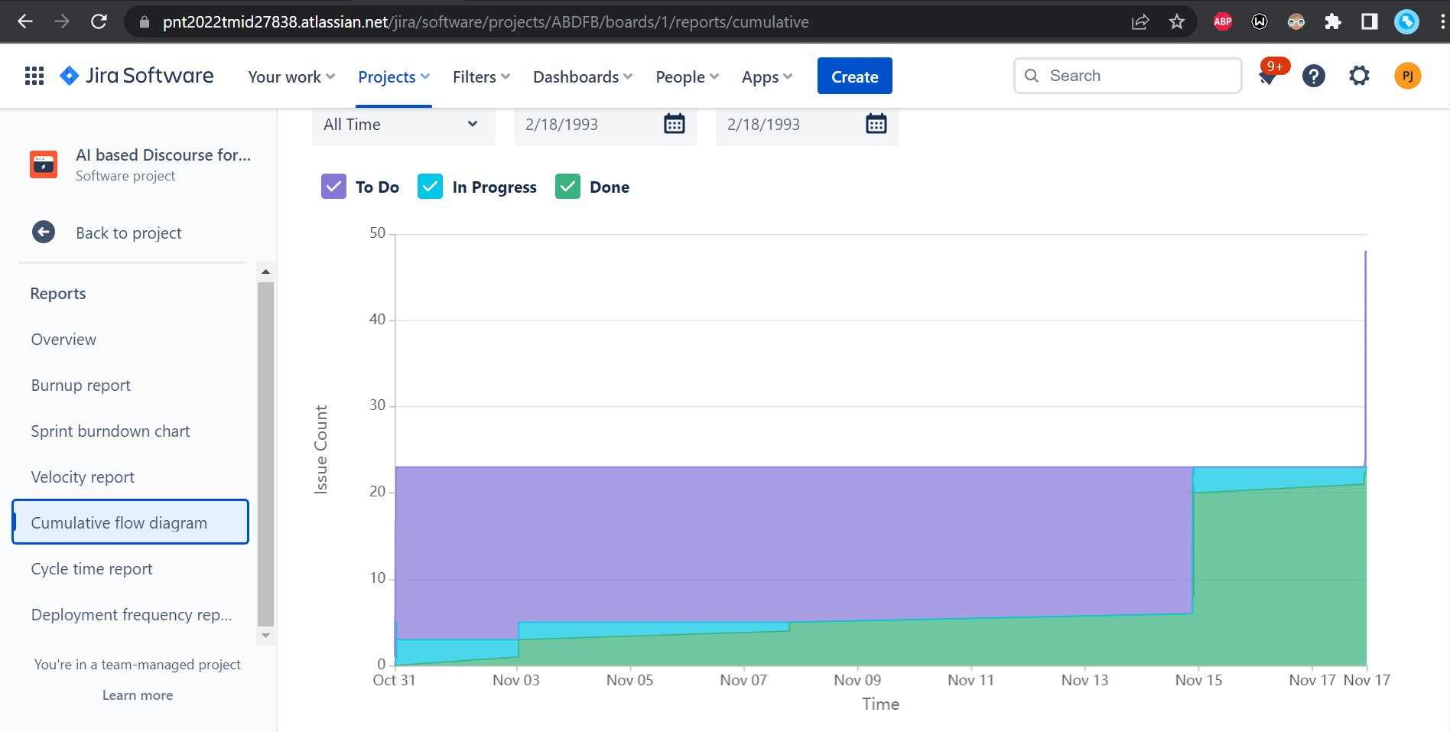

1. **CODING & SOLUTIONING (Explain the features added in the project along with code)**

## Feature 1

## Python Flask

Python Flask is used to develop chatbot applications using python. Flask is mainly used to render and integrate the chatbot application in the browser by providing API. By running the python application, the suitable server domain link is obtained and run in the browser.

## HTML

The HTML and CSS is used to design the overall chatbot UI**.** HTML is used to add UI components and CSS is used to add style to those components. IBM watson assistant deploys

HTML code to train the Chatbot.

<html lang="en">

<head>

<title>AI BASED DISCOURSE FOR BANKING INDUSTRY</title>

</head>

<body>

<div class="main">

<div class="navbar">

<div class="icon">

<h2 class="logo">BankBot</h2>

</div>

<div class="menu">

<ul>

<li><a href="#">HOME</a></li>

<li><a href="#">SERVICE</a></li>

<li><a href="#">CONTACT</a></li>

<li><a href="#">ABOUT</a></li>

</ul>

</div>

</div>

<div class="content">

<h1>AI Based Discourse for <br><span>Banking</span> <br>Industry</h1>

<br>

<button class="cn"><a href="#">JOIN US</a></button>

</div>

</div>

<script>

window.watsonAssistantChatOptions = {

integrationID: "c3bff345-f26d-47d8-94a4-459ade939da1", // The ID of this integration.

region: "us-south", // The region your integration is hosted in.

serviceInstanceID: "84a4d536-ad71-4db7-965b-dc28a31315e6", // The ID of your service instance.

onLoad: function(instance) { instance.render(); }

};

setTimeout(function(){

const t=document.createElement('script');

t.src="https://web-chat.global.assistant.watson.appdomain.cloud/versions/" + (window.watsonAssistantChatOptions.clientVersion || 'latest') + "/WatsonAssistantChatEntry.js";

document.head.appendChild(t);

});

</script>

</body>

</html>

## Feature 2 IBM CHATBOT:

* + - Our chatbot is able to guide a customer to create a bank account.(Both current and savings account)
    - Our chatbot is able to answer loan queries.
    - Our chatbot is able to answer general banking queries.
    - Our chatbot is able to answer queries regarding net banking.

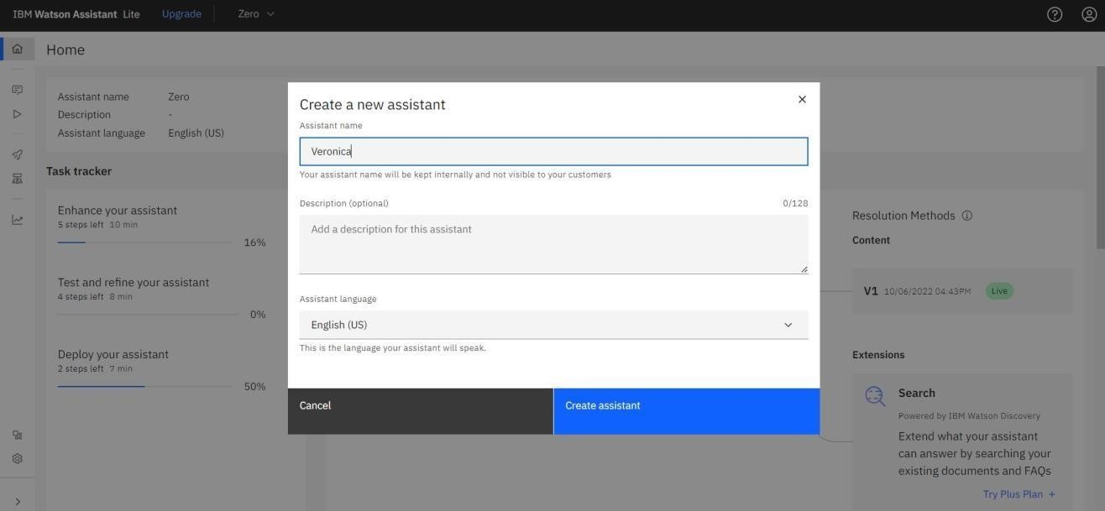

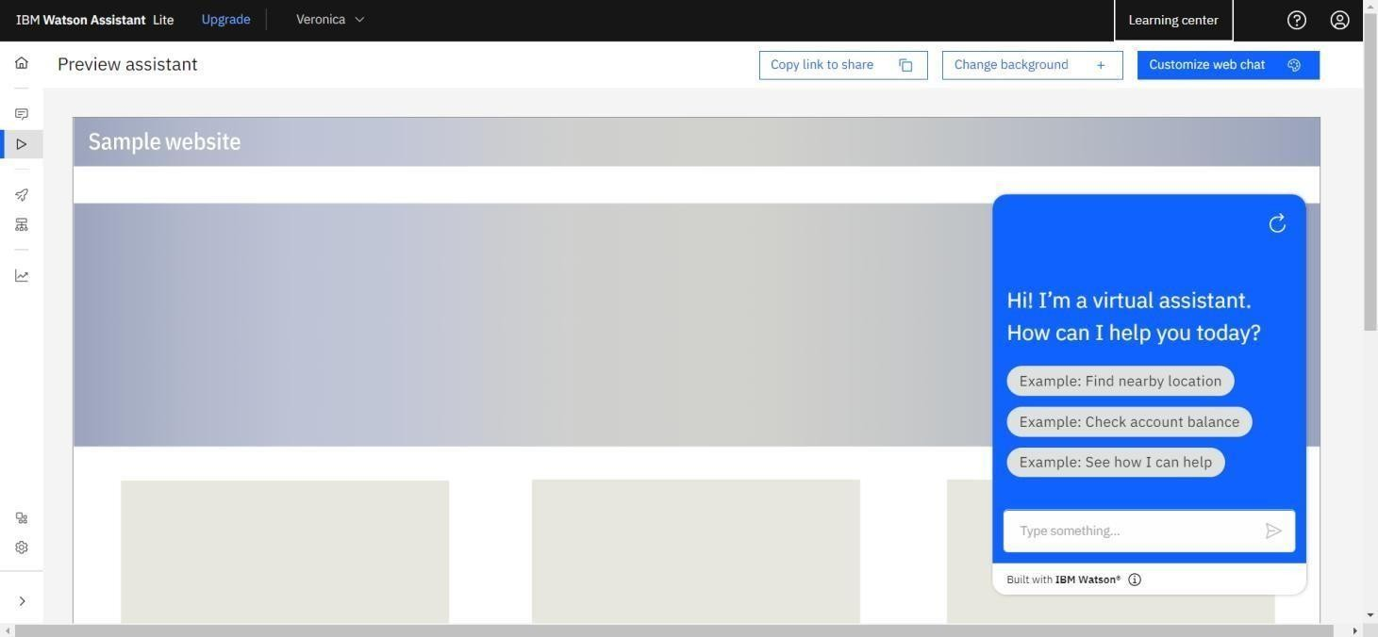

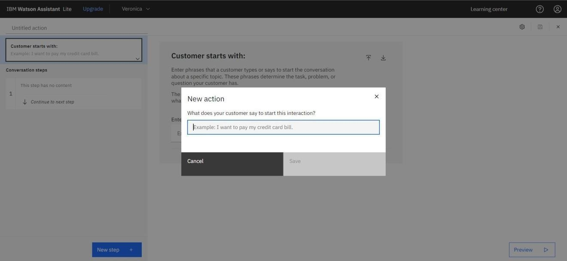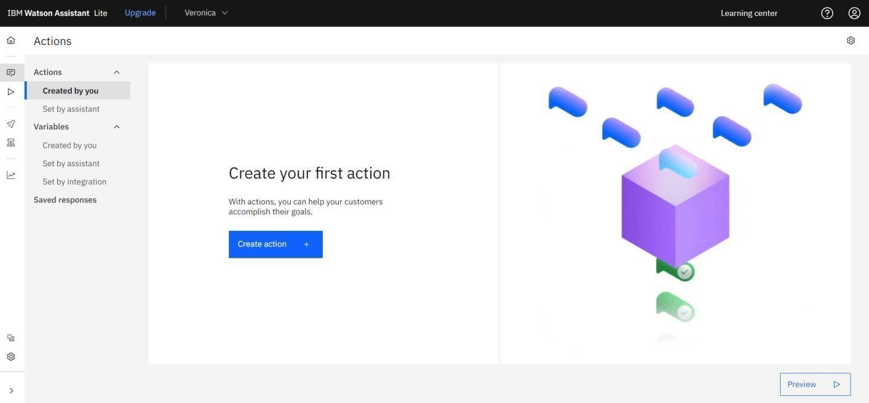

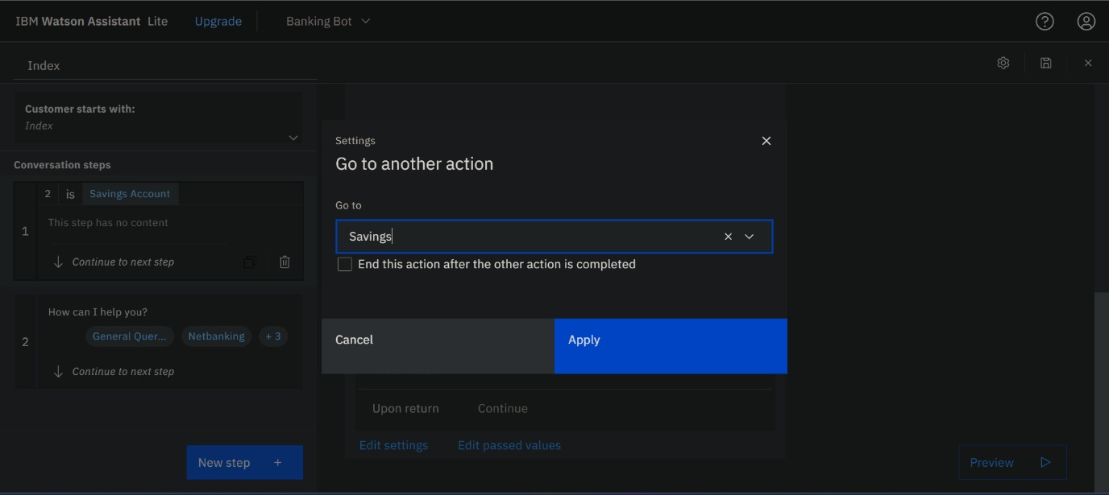

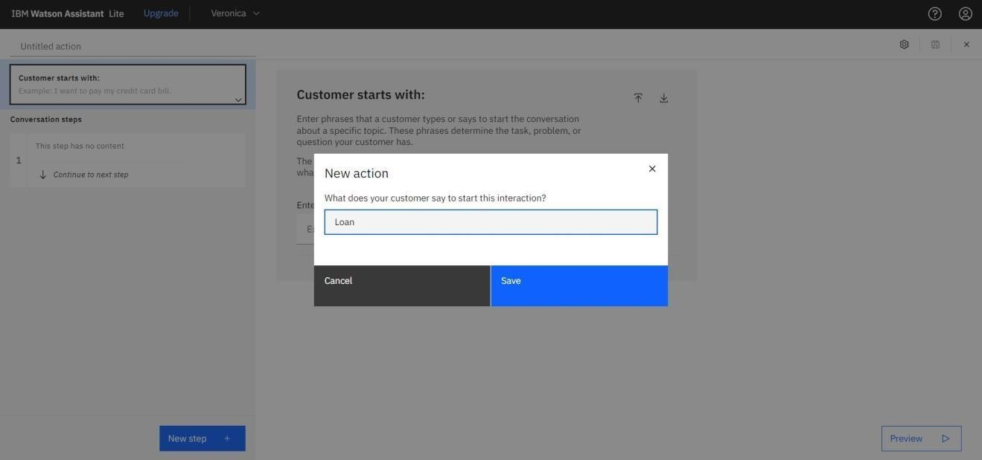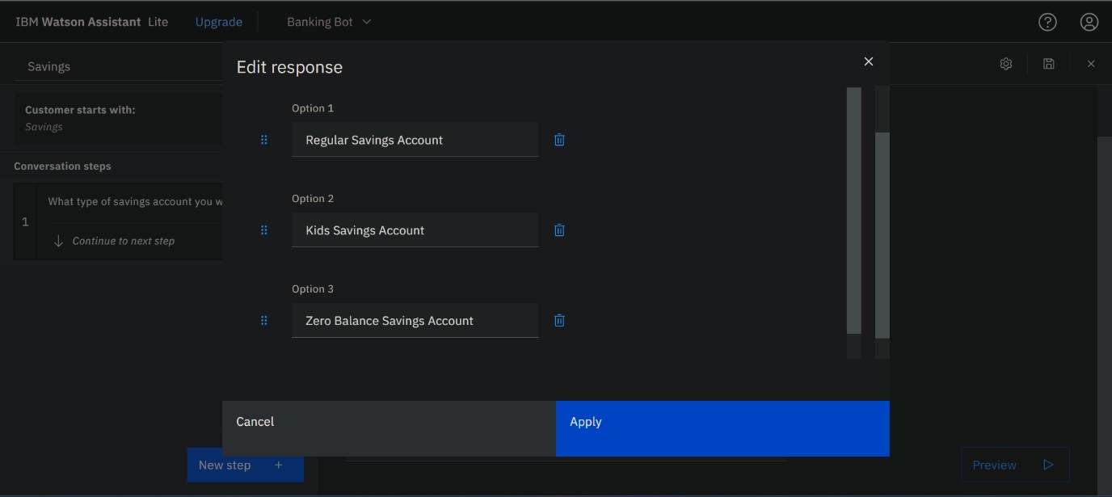

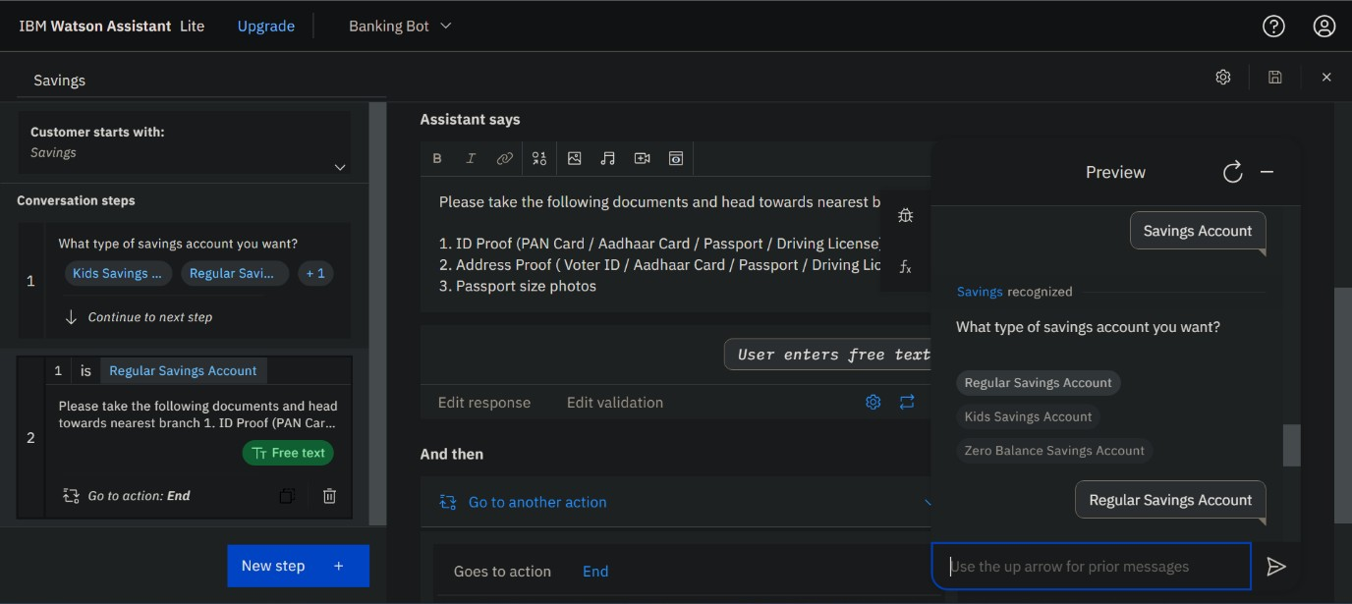

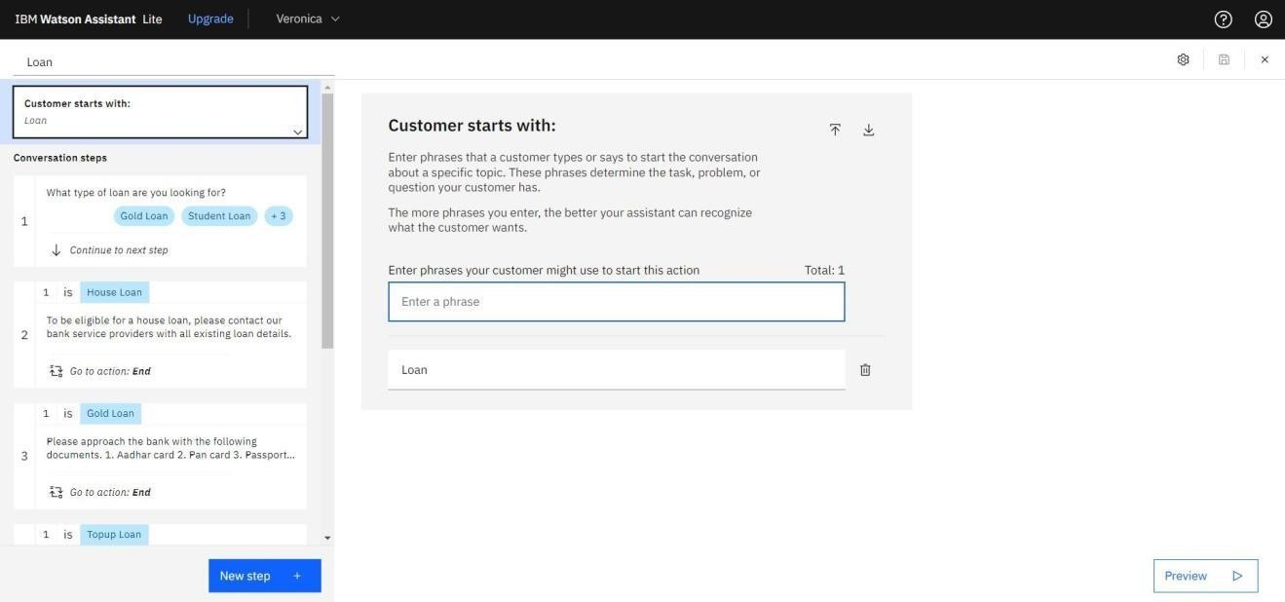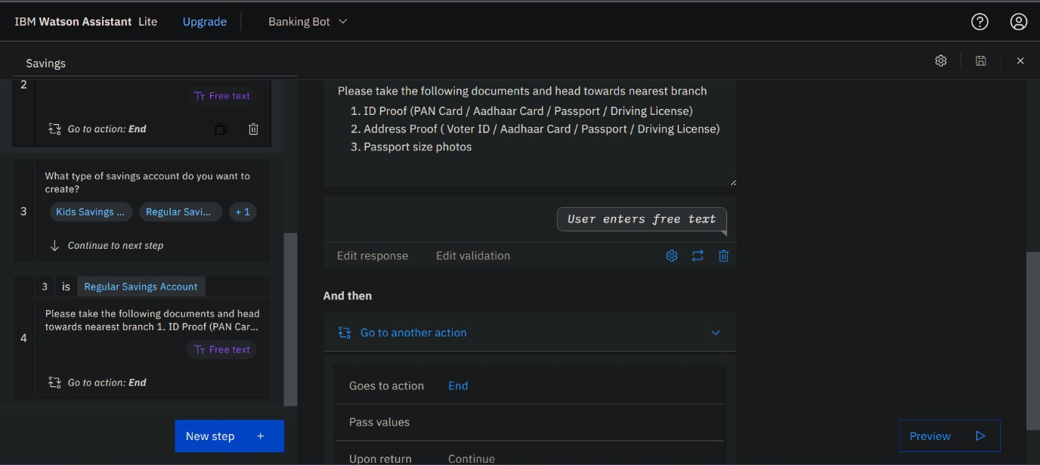

## TESTING

* 1. **Test Cases**

|  |  |
| --- | --- |
|  | **Test Scenarios** |
| 1 | Verify user is able to open and view chatbot UI |
| 2 | Verify user is able to interact with chatbot or not |
| 3 | Verify chatbot is able to respond to user queries immediately |
| 4 | Verify chatbot is able to provide options for user to choose various choices |
|  |  |
|  | **Savings Account Related Actions** |
| 1 | Verify user is able to select type of savings account |
| 2 | Verify user is able to know the procedure to create savings account for selected type |
| 3 | Verify user is check the minimum balance |
| 4 | Verify user is able to find interest rate |
|  |  |
|  | **Current Account Related Actions** |
| 1 | Verify user is able to select type of company |
| 2 | Verify user is able to know the procedure to create current account for selected type |
| 3 | Verify user is able to know about zero balance current account |
| 4 | Verify user is able to know the procedure to close current account |
|  |  |
|  | **Loan Account Related Actions** |
| 1 | Verify user is able to choose options for selecting type of available loan policies |
| 2 | Verify user is able to know about available loan amounts |
| 3 | Verify user is able to check the loan status |
| 4 | Verify user is able to know about joint loan |
|  |  |
|  | **General Query Related Actions** |
| 1 | Verify user is able to know about bank working days |
| 2 | Verify user is able to know about list of branches |
| 3 | Verify user is able to find the nearest branch |
| 4 | Verify user is able to know about storage locker facility |
| 5 | Verify user is able to know about currency conversion facility |
|  |  |
|  | **Net banking Related Actions** |
| 1 | Verify user is able to know the procedure to login netbanking account |
| 2 | Verify user is able to know the procedure to change netbanking password |
| 3 | Verify user is able to choose options for selecting type of fund transfers |
| 4 | Verify user is able to know about daily transaction limit |

## User Acceptance Testing

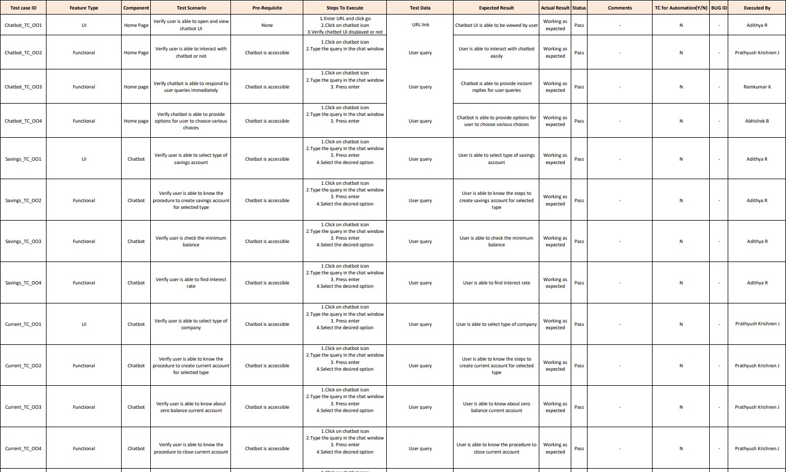

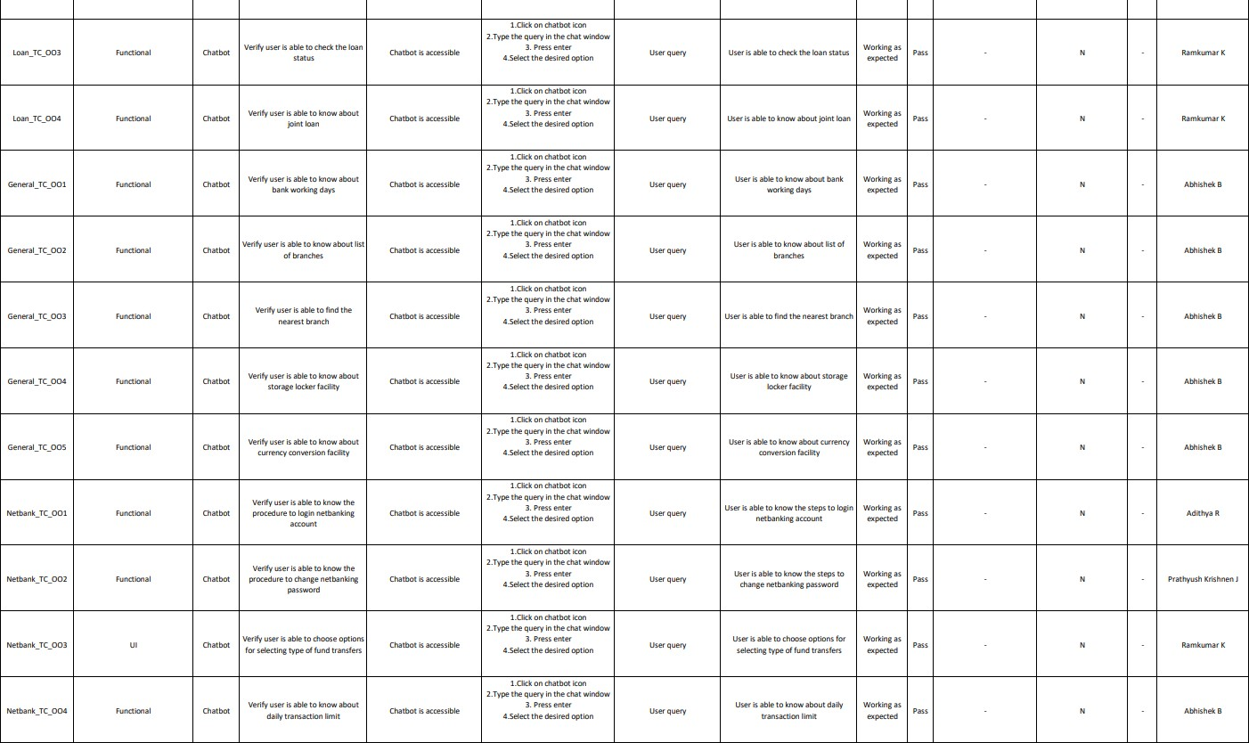

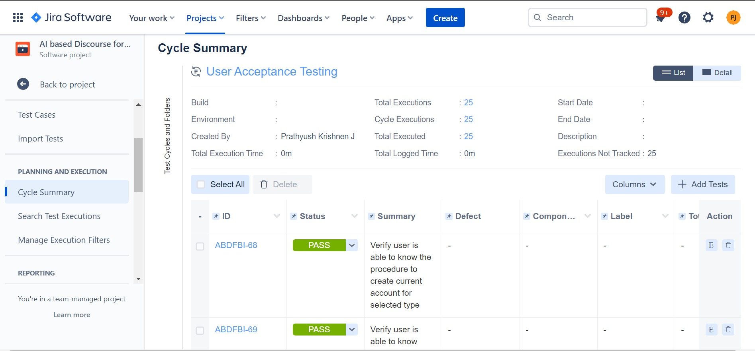

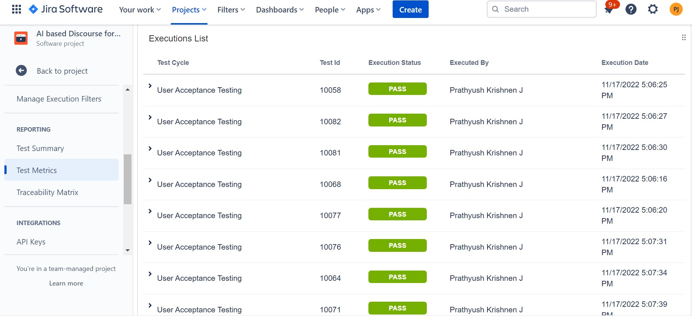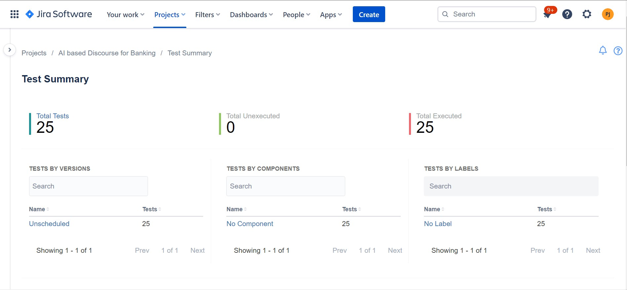

**Test Report**

## Purpose of Document

The purpose of this document is to briefly explain the test coverage and open issues of the AI based Discourse for Banking Industry project at the time of the release to User Acceptance Testing (UAT).

## Defect Analysis

|  |  |  |  |  |  |
| --- | --- | --- | --- | --- | --- |
| **Resolution** | **Severity 1** | **Severity 2** | **Severity 3** | **Severity 4** | **Subtotal** |
| By Design | 0 | 0 | 2 | 1 | 3 |
| Duplicate | 0 | 0 | 0 | 0 | 0 |
| External | 0 | 0 | 0 | 0 | 0 |
| Fixed | 0 | 0 | 2 | 1 | 3 |
| Not Reproduced | 0 | 0 | 0 | 0 | 0 |
| Skipped | 0 | 0 | 0 | 0 | 0 |
| Won't Fix | 0 | 0 | 0 | 0 | 0 |
| Totals |  | 0 | 2 | 2 | 6 |

* + 1. **Test Case Analysis**

|  |  |  |  |  |
| --- | --- | --- | --- | --- |
| **Section** | **Total Cases** | **Not Tested** | **Fail** | **Pass** |
| Print Engine | 0 | 0 | 0 | 0 |
| Client Application | 25 | 0 | 0 | 25 |
| Security | 0 | 0 | 0 | 0 |
| Outsource Shipping | 0 | 0 | 0 | 0 |
| Exception Reporting | 0 | 0 | 0 | 0 |
| Final Report Output | 25 | 0 | 0 | 25 |
| Version Control | 0 | 0 | 0 | 0 |

# RESULTS

## 9.1 Performance Metrics Model Performance Testing:

|  |  |  |  |
| --- | --- | --- | --- |
| **S.NO**  **.** | **PARAMETER** | **VALUES** | **SCREENSHOT** |
| 1. | Model Summary | The chatbot is used by the user to interact and select queries that are populated based on frequently asked questions of banking customers. There can be multiple instances of a single chatbot serving different users at the same time. It quickly responds with expected answers to frequently asked customer queries. It can be scaled as per the requirements of the bank to include answers to queries related to any new feature or service introduced by the bank. |  |

|  |  |  |  |
| --- | --- | --- | --- |
| 2. | Accuracy | Training Accuracy  – 100%  Validation Accuracy – 100% |  |

* + - 1. **ADVANTAGES AND DISADVANTAGES**

## Advantages

1. **Round-the-clock support:** Chatbots provide 24/7 client support, so existing and potential customers can try and solve their banking problems after work hours and on weekends. This ultimately also leads to better customer experience.
2. **Enhanced productivity of bank personnel**: Not all clients’ problems require the help of a staff member. Artificial intelligence may successfully deal with minor issues leaving only the most urgent and complicated cases for the human approach.
3. **More convenient mode of communication**: Chatbots may combine various functionalities that would make them convenient for customers of different age groups.

## Disadvantages

1. **Internet Issues:** Chatbots will not work without the internet.If there is a network problem,chatbots may stop working and will not respond to client queries.
2. **Requirement of technical knowledge**: Users who make use of chatbots must know how to use chatbots.Otherwise, it is difficult to do interaction with chatbot.
3. **Providing unexpected answers**: Chatbots in some cases may get confused due to prolonged user inputs and may provide irrelevant answers.
4. **Inability to interpret multiple queries**: Chatbots can’t understand multiple questions at a time if a user continuously posts queries to it. So it is necessary for a user to post queries one-by-one.

## CONCLUSION

Chatbots developed using AI are able to answer any frequently asked banking queries on account creation, loan, net banking, other services etc. It addresses the queries of customers immediately and effectively in a cost efficient manner. It eliminates the need for a massive customer care workforce and even reduces the workload of the bank employees whose efforts can be used elsewhere. AI Chatbots provides 24/7 service to clear all customer queries and guide them through all the banking processes. It can be scaled as per the requirements of the bank to include answers to queries related to any new feature or service introduced by the bank. In order to overcome the user satisfaction issues associated with banking services, chatbot will provide personal and efficient communication between the user and the bank. It is built to be the overall virtual assistant that can facilitate customers to ask banking-related questions without visiting the bank or calling up customer service centers as well as providing them with relevant suggestions.

## FUTURE SCOPE

Chatbots help people obtain the information they need and solve their problems. The technology sector has seen a massive increase in AI development, which has led to the creation of chatbots that can help users easily find the information they need online. AI Chatbots effectively create a strong brand image. They will continue to evolve and play an important role in customer service for businesses.

1. Bots for Internal Business Communications

Chatbots can be used for various purposes, including addressing common problems, communicating with employees, and finishing HR-related tasks and transactional functions. Chatbots for websites are acting as a guide to new employees through company protocols, recording answers for screen questions, and assisting with the onboarding process for new employees. Chatbots can save time for IT desk agents and help with more complicated issues.

1. Content Marketing

Chatbots can communicate with the target market by speaking with them in complete sentences with a natural and easy-going conversational flow. Some markets use these bots to serve customer service and retail, amongst others. Chatbots can segment consumers for future marketing campaigns. This can be incredibly useful for creating more accurate target marketing. Based on the information from dialogue with chatbots, marketers can use this information to help with personalizing brand content.

1. Social Media

Chatbots have better customer interaction rates on social media. Chatbot interactions [increase](https://www.facebook.com/business/marketing/messenger) [consumer confidence](https://www.facebook.com/business/marketing/messenger) in a brand or business. Customers are informed with daily or weekly announcements about deals, events, and promotions via social media.With time, it is used for voicing opinions, ordering products and services, offering reviews, and even getting in touch with businesses.

1. Use of AI in contact centers

AI chatbots without human involvement can handle simple requests such as changing a password, requesting a balance, scheduling an appointment, etc.

**13. APPENDIX**

# Source Code

***Build PYTHON FLASK Code:***

**APP.PY**

**from flask import Flask, render_template**

**app = Flask(_name_, template_folder='templates')**

**@app.route('/')**

**def home():**

**return render_template('step1.html')**

**if _name_ == '_main_':**

**app.run(debug=True)**

***Build HTML and CSS Code***

## HOME.HTML

<html lang="en">

<head>

<title>AI BASED DISCOURSE FOR BANKING INDUSTRY</title>

</head>

<body>

<div class="main">

<div class="navbar">

<div class="icon">

<h2 class="logo">BankBot</h2>

</div>

<div class="menu">

<ul>

<li><a href="#">HOME</a></li>

<li><a href="#">SERVICE</a></li>

<li><a href="#">CONTACT</a></li>

<li><a href="#">ABOUT</a></li>

</ul>

</div>

</div>

<div class="content">

<h1>AI Based Discourse for <br><span>Banking</span> <br>Industry</h1>

<br>

<button class="cn"><a href="#">JOIN US</a></button>

</div>

</div>

<script>

window.watsonAssistantChatOptions = {

integrationID: "c3bff345-f26d-47d8-94a4-459ade939da1", // The ID of this integration.

region: "us-south", // The region your integration is hosted in.

serviceInstanceID: "84a4d536-ad71-4db7-965b-dc28a31315e6", // The ID of your service instance.

onLoad: function(instance) { instance.render(); }

};

setTimeout(function(){

const t=document.createElement('script');

t.src="https://web-chat.global.assistant.watson.appdomain.cloud/versions/" + (window.watsonAssistantChatOptions.clientVersion || 'latest') + "/WatsonAssistantChatEntry.js";

document.head.appendChild(t);

});

</script>

</body>

</html>

**STYLE**

<style>

*{

margin: 0;

padding: 0;

}

.main{

width: 100%;

background: linear-gradient(to top, rgba(0,0,0,0.5)50%,rgba(0,0,0,0.5)50%), url("https://images.cointelegraph.com/images/1434_aHR0cHM6Ly9zMy5jb2ludGVsZWdyYXBoLmNvbS91cGxvYWRzLzIwMjEtMDUvNmNmNmJlZWItM2ZjMS00OThiLTllMDktMzVjYzE1ODMyMGEyLmpwZw==.jpg");

background-position: 0%;

background-repeat: no-repeat;

background-size: cover;

height: 100vh;

filter: brightness(1.5);

}

.navbar{

width: 1200px;

height: 75px;

margin: auto;

}

.icon{

width: 200px;

float: left;

height: 70px;

}

.logo{

color: #fff;

font-size: 35px;

font-family: Arial;

padding-left: 20px;

float: left;

padding-top: 10px;

margin-top: 5px

}

.menu{

width: 400px;

float: left;

height: 70px;

}

ul{

float: left;

display: flex;

justify-content: center;

align-items: center;

}

ul li{

list-style: none;

margin-left: 62px;

margin-top: 27px;

font-size: 14px;

}

ul li a{

text-decoration: none;

color: #fff;

font-family: Arial;

font-weight: bold;

transition: 0.4s ease-in-out;

}

ul li a:hover{

color: #3857cf;

}

.search{

width: 330px;

float: left;

margin-left: 270px;

}

.srch{

font-family: 'Times New Roman';

width: 200px;

height: 40px;

background: transparent;

border: 1px solid #ff7200;

margin-top: 13px;

color: #fff;

border-right: none;

font-size: 16px;

float: left;

padding: 10px;

border-bottom-left-radius: 5px;

border-top-left-radius: 5px;

}

.btn{

width: 100px;

height: 40px;

background: #ff7200;

border: 2px solid #ff7200;

margin-top: 13px;

color: #fff;

font-size: 15px;

border-bottom-right-radius: 5px;

border-bottom-right-radius: 5px;

transition: 0.2s ease;

cursor: pointer;

}

.btn:hover{

color: #000;

}

.btn:focus{

outline: none;

}

.srch:focus{

outline: none;

}

.content{

width: 1200px;

height: auto;

margin: auto;

color: white;

position: relative;

}

.content .par{

padding-left: 20px;

padding-bottom: 25px;

font-family: Arial;

letter-spacing: 1.2px;

line-height: 30px;

}

.content h1{

font-family: 'Times New Roman';

font-size: 50px;

padding-left: 20px;

margin-top: 9%;

letter-spacing: 2px;

}

.content .cn{

width: 160px;

height: 40px;

background:#3857cf;

border: none;

margin-bottom: 10px;

margin-left: 20px;

font-size: 18px;

border-radius: 10px;

cursor: pointer;

transition: .4s ease;

}

.content .cn a{

text-decoration: none;

color: #000;

transition: .3s ease;

}

.cn:hover{

background-color: #fff;

}

.content span{

color: #3857cf;

font-size: 65px

}

.form{

width: 250px;

height: 380px;

background: linear-gradient(to top, rgba(0,0,0,0.8)50%,rgba(0,0,0,0.8)50%);

position: absolute;

top: -20px;

left: 870px;

transform: translate(0%,-5%);

border-radius: 10px;

padding: 25px;

}

.form h2{

width: 220px;

font-family: sans-serif;

text-align: center;

color: #ff7200;

font-size: 22px;

background-color: #fff;

border-radius: 10px;

margin: 2px;

padding: 8px;

}

.form input{

width: 240px;

height: 35px;

background: transparent;

border-bottom: 1px solid #ff7200;

border-top: none;

border-right: none;

border-left: none;

color: #fff;

font-size: 15px;

letter-spacing: 1px;

margin-top: 30px;

font-family: sans-serif;

}

.form input:focus{

outline: none;

}

::placeholder{

color: #fff;

font-family: Arial;

}

.btnn{

width: 240px;

height: 40px;

background: #ff7200;

border: none;

margin-top: 30px;

font-size: 18px;

border-radius: 10px;

cursor: pointer;

color: #fff;

transition: 0.4s ease;

}

.btnn:hover{

background: #fff;

color: #ff7200;

}

.btnn a{

text-decoration: none;

color: #000;

font-weight: bold;

}

.form .link{

font-family: Arial, Helvetica, sans-serif;

font-size: 17px;

padding-top: 20px;

text-align: center;

}

.form .link a{

text-decoration: none;

color: #ff7200;

}

.liw{

padding-top: 15px;

padding-bottom: 10px;

text-align: center;

}

.icons a{

text-decoration: none;

color: #fff;

}

.icons ion-icon{

color: #fff;

font-size: 30px;

padding-left: 14px;

padding-top: 5px;

transition: 0.3s ease;

}

.icons ion-icon:hover{

color: #ff7200;

}

</style>

## IBM CHATBOT:

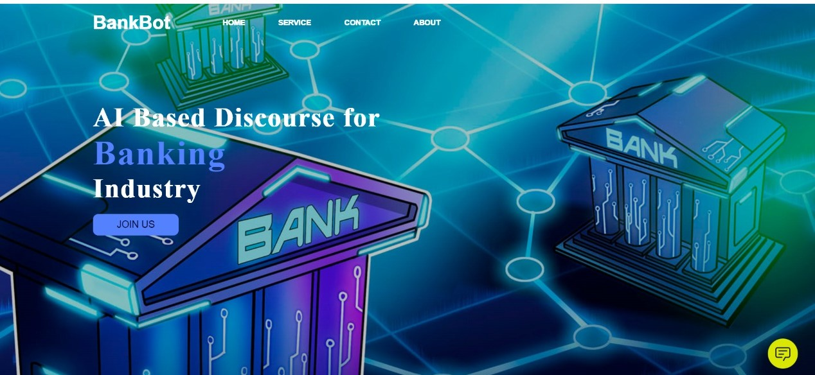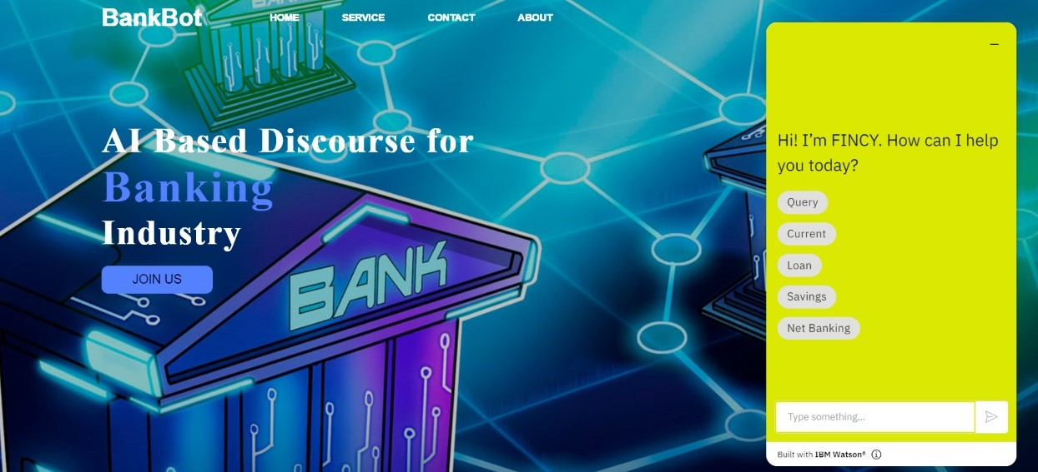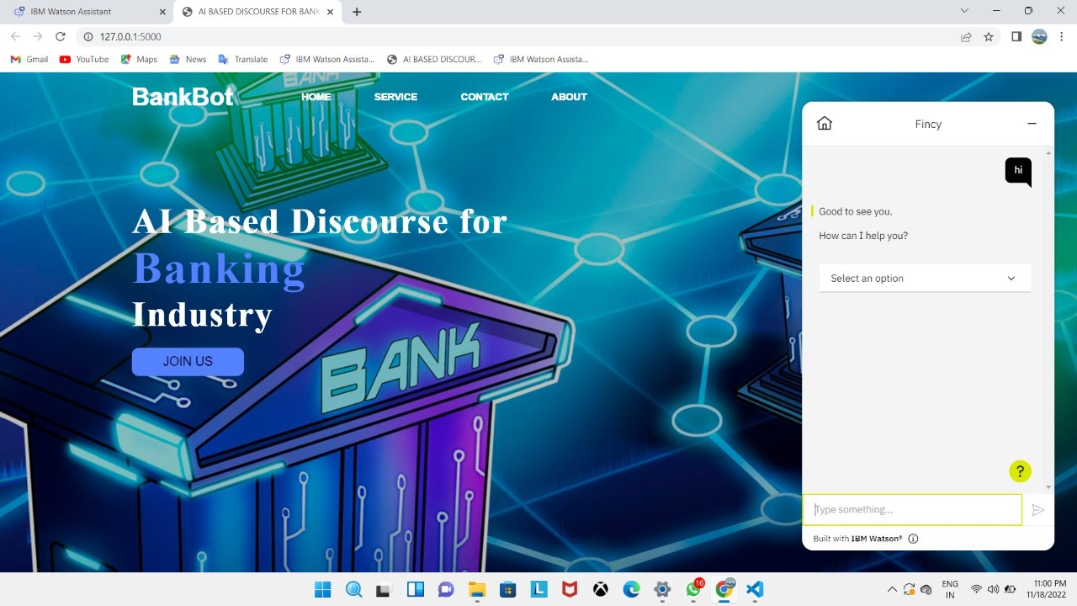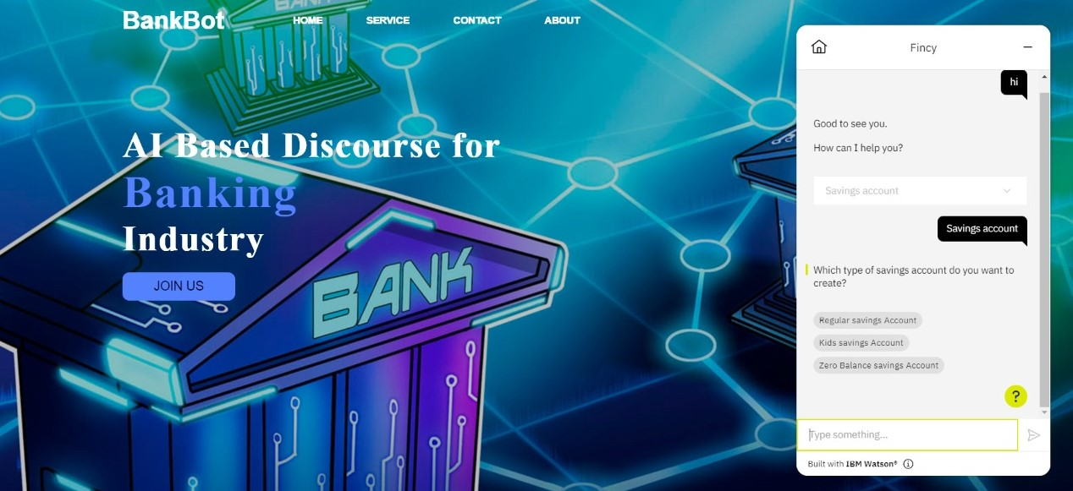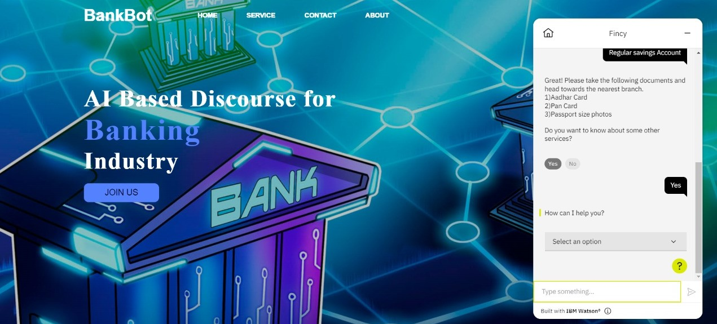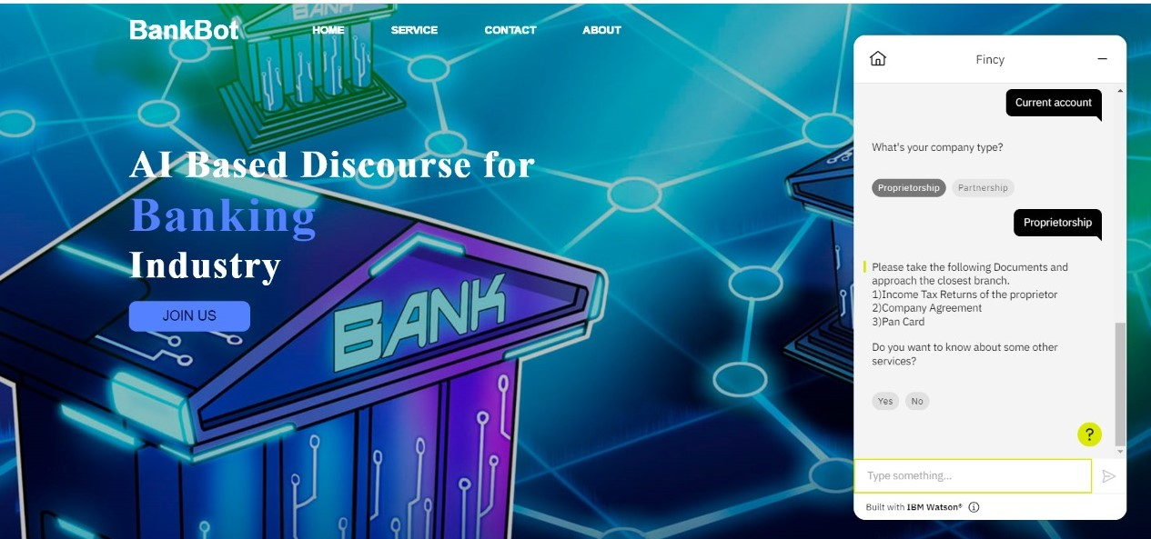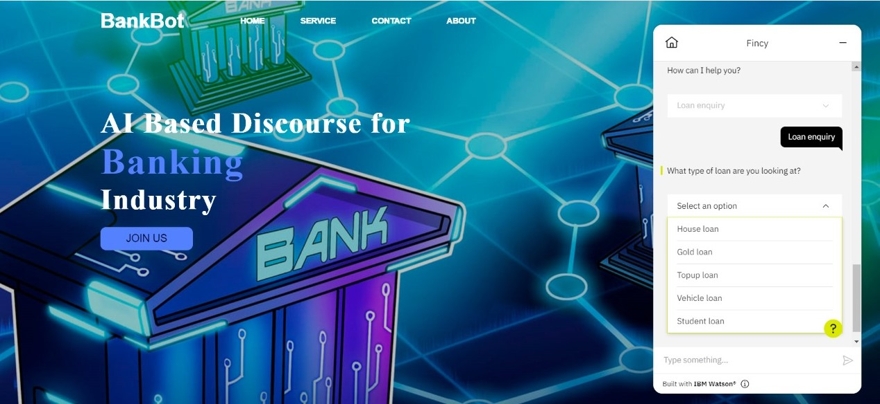

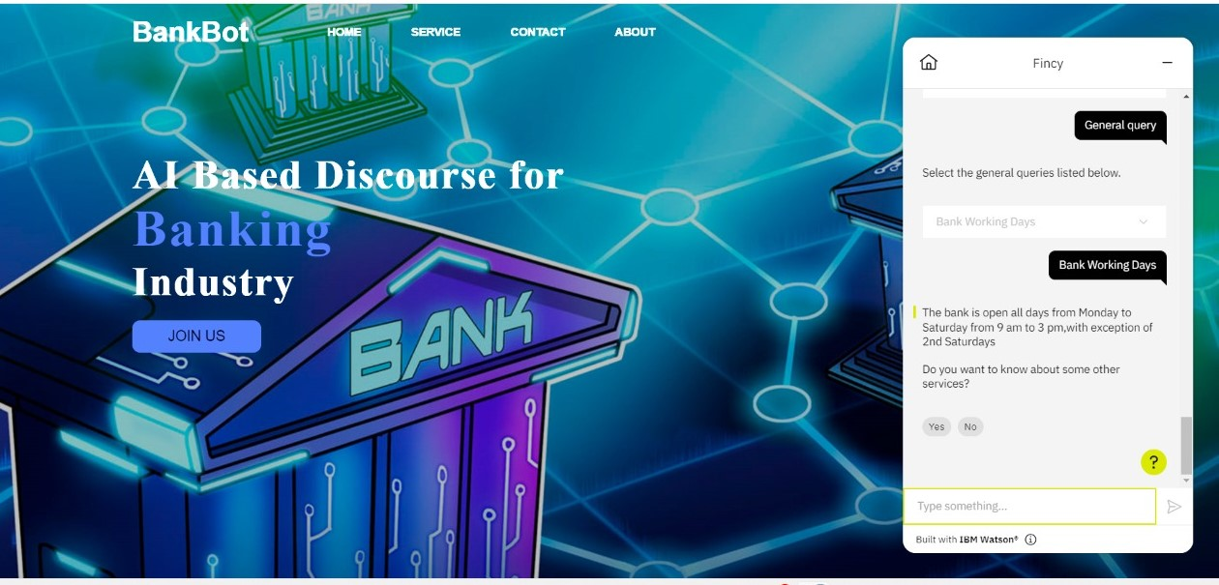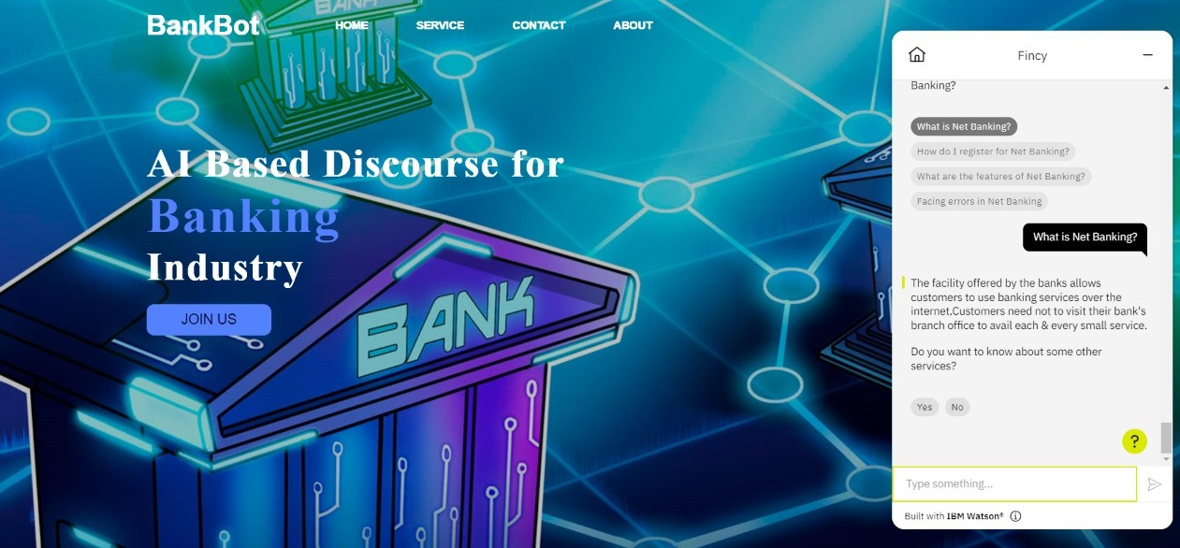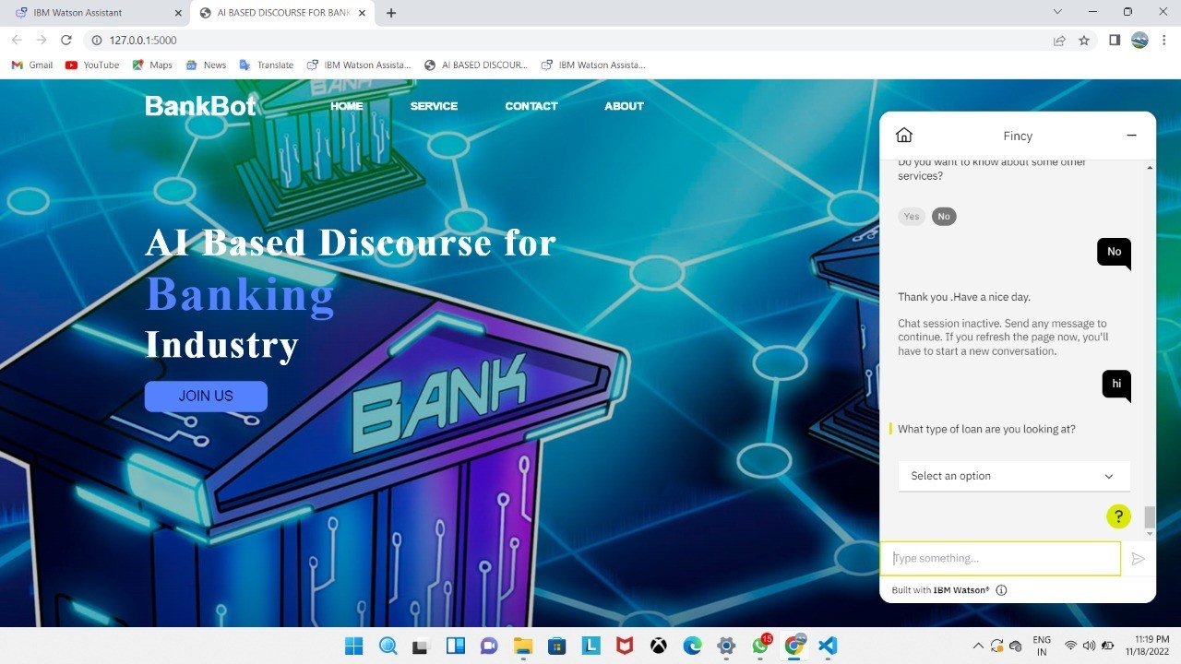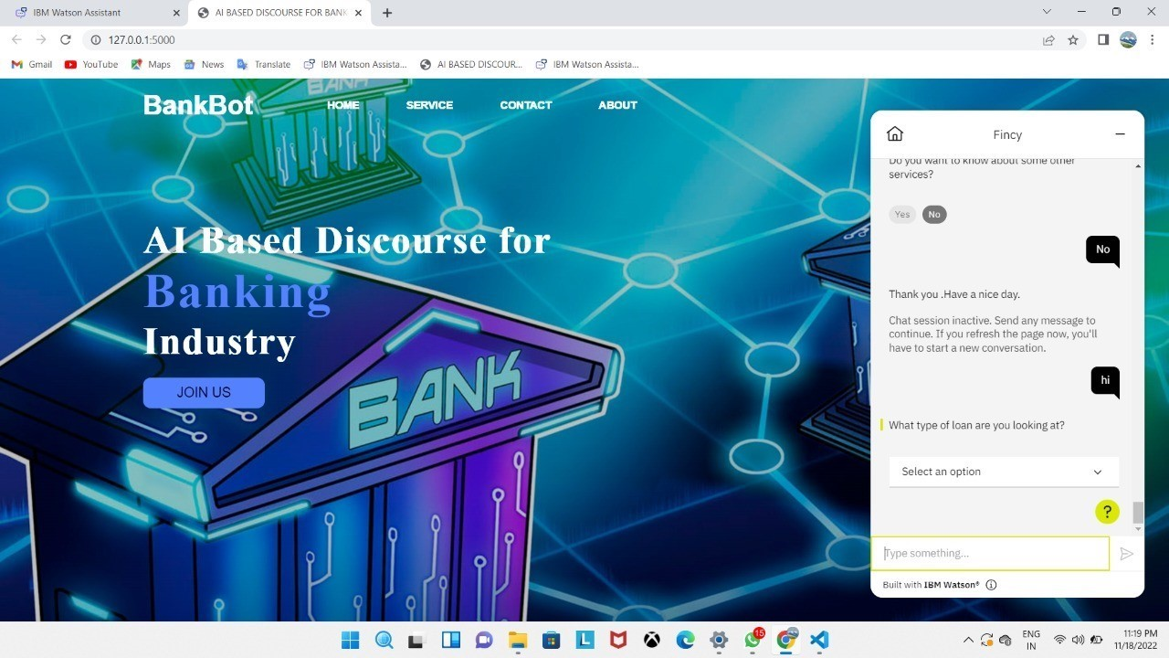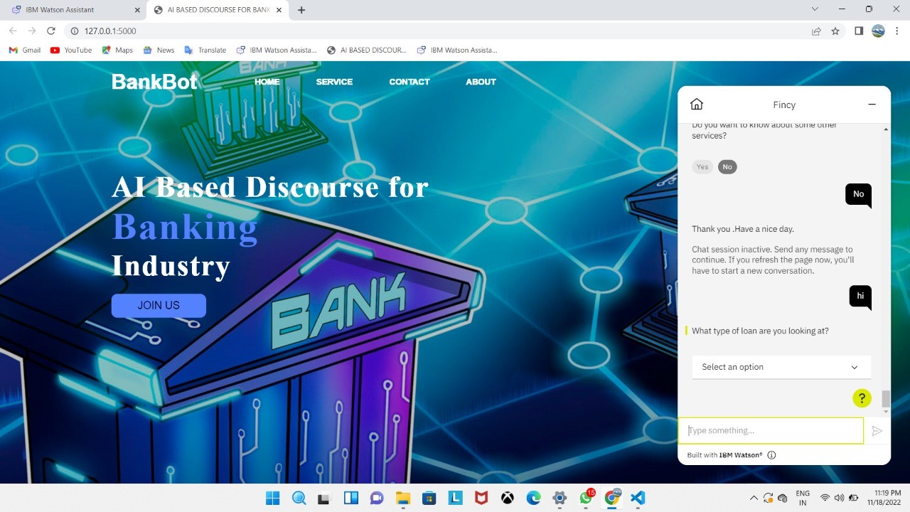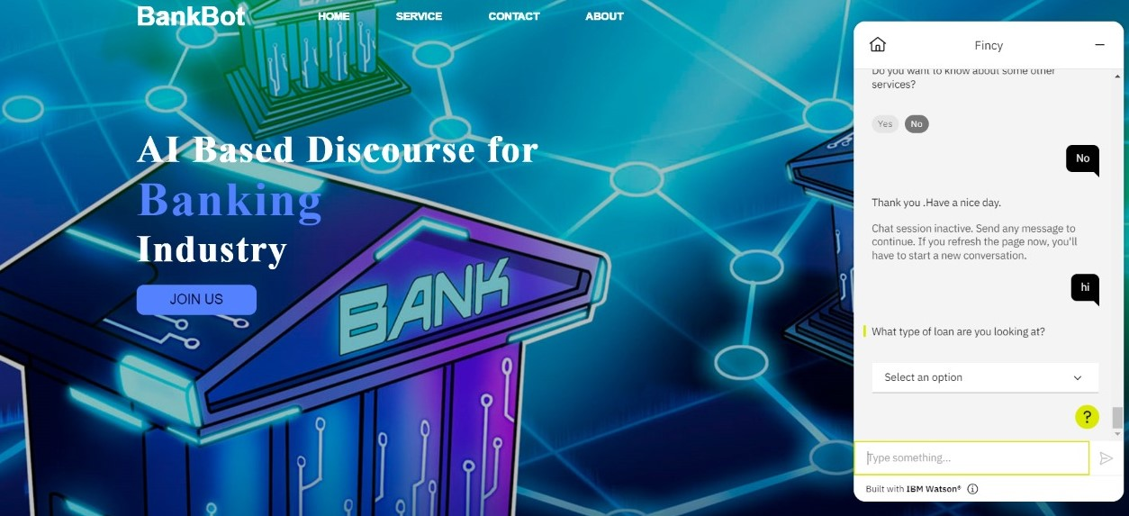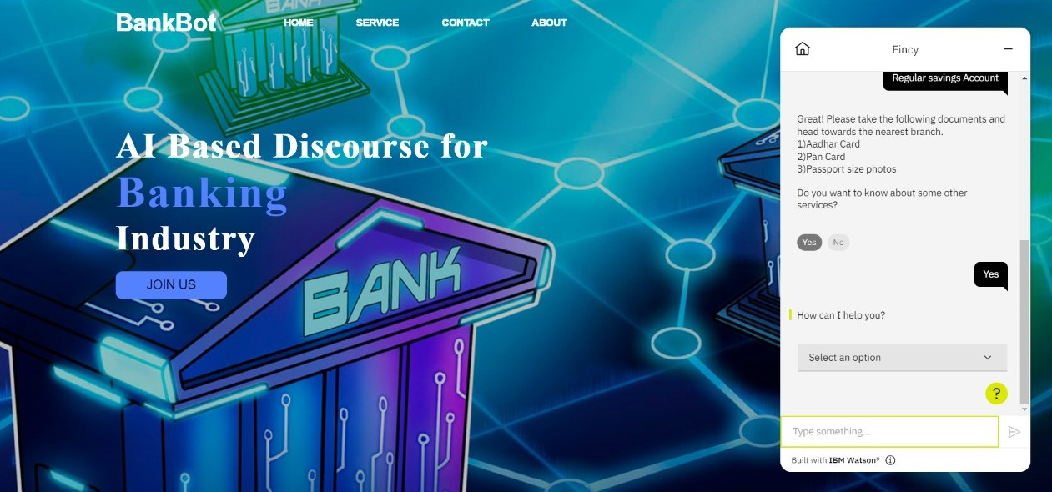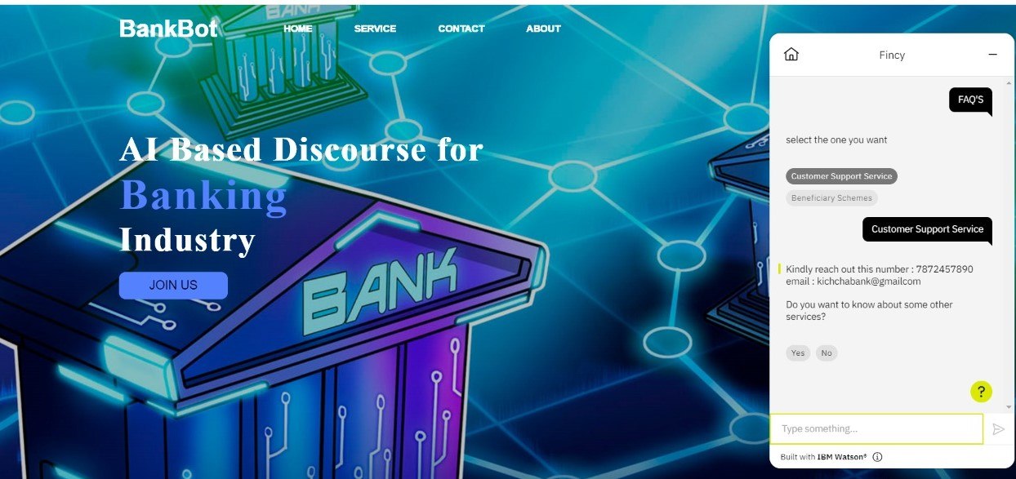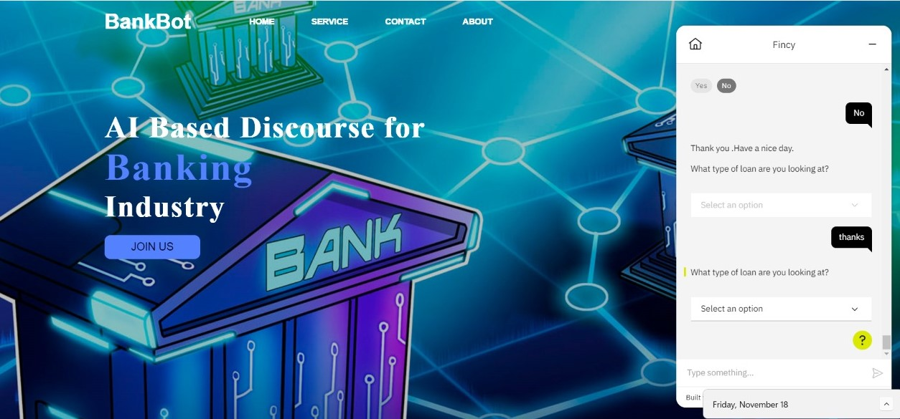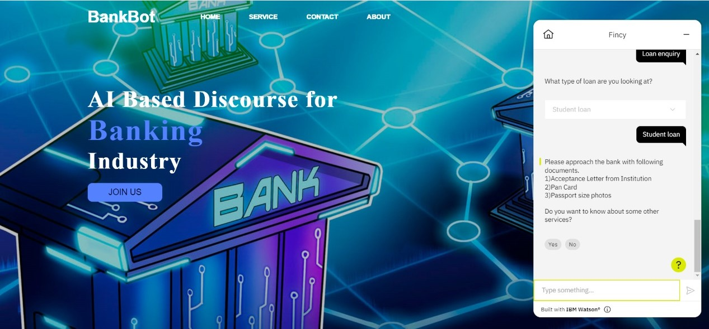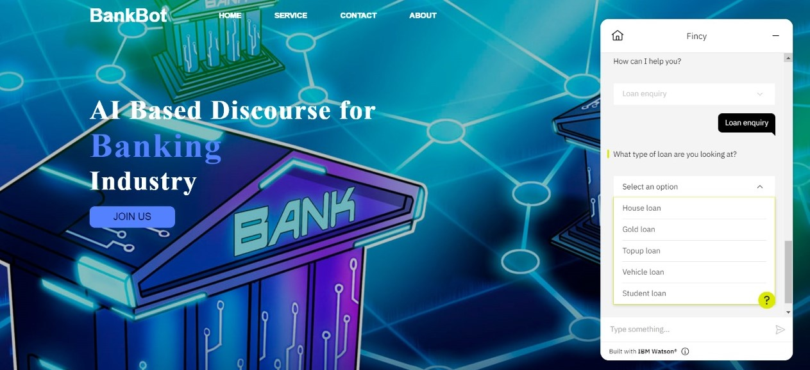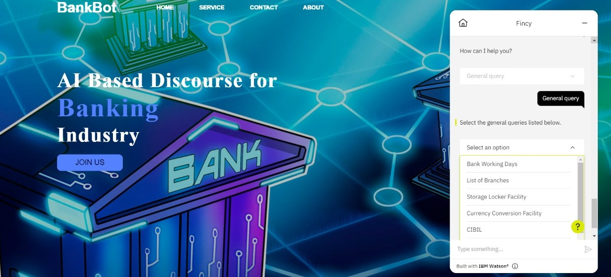



**GITHUB LINK:**

https://github.com/IBM-EPBL/IBM-Project-2855-1658484464

## PROJECT DEMO LINK:

## https://vimeo.com/774094109